INTRODUCTION
The term anatomy literally means to cut apart; it is the study of the composition and structure of the body and its tissues. Science that deals with the form and structure of all organisms. In contrast to anatomy, which deals primarily with structure.
physiology is the study of the integrated functions of the body and the functions of all its parts (systems, organs, tissues, cells, and cell components), including biophysical and biochemical processes.

Branches of anatomy;
- Gross (macroscopic) anatomy. This is the study of the form and relations (relative positions) of the structures of the body that can be seen with the unaided eye.

- Comparative anatomy is a study of the structures of various species of animals, with particular emphasis on those characteristics that aid in classification.

- Embryology is the study of developmental anatomy, covering the period from conception (fertilization of the egg) to birth.

- Microscopic anatomy or histology. Another large branch of anatomy consists of the study of tissues and cells that can be seen only with the aid of a microscope.

Physiology has also become so extensive in scope that many areas of specialization are recognized. Like anatomy, these may be based on body systems (e.g., neurophysiology, gastrointestinal physiology, cardiovascular physiology, respiratory physiology, endocrine physiology, and reproductive physiology) or the level of biological organization (cell physiology and organismal physiology).

Nomenclatures;
Osteology ; study of the Bones and Skeletal system
Arthrology ; study of the Articular system and Joints
My ology; study of the Muscular system and muscles
Splanchnology; study of the systems of the body which includes; Digestive system, Respiratory system, Urinary system, Reproductive system, Endocrine system, Nervous system, Circulatory system and Sensory system .

Cranial is a directional term meaning toward the head. The shoulder is cranial to the hip; It is closer to the head than is the hip.
Caudal means toward the tail. The rump is caudal to the loin. Rostral and caudal are directional terms used in reference to features of the head to mean toward the nose (rostral) or toward the tail (caudal).
The median plane is an imaginary plane passing through the body so as to divide the body into equal right and left halves.
Medial is an adjective meaning close to or toward the median plane. The heart is medial to the lungs; it is closer to the median plane than are the lungs. The chestnut is on the medial aspect (inside) of a horse’s limb; it is on the side closest to the median plane.
Lateral is the antonym of medial; it means away from the median plane. The ribs are lateral to the lungs, that is, farther from the median plane.
Dorsal means toward or beyond the backbone or vertebral column. The kidneys are dorsal to the intestines; they are closer to the vertebral column on the dorsum of a horse.
Ventral means away from the vertebral column or toward the mid abdominal wall. The udder is the most ventral part of the body of a cow, the part of the body farthest from the vertebral column.
Deep and internal indicate proximity to the center of an anatomical structure. The humerus (arm bone) is deep in relation to all other structures in the arm.
Superficial and external refer to proximity to the surface of the body.
Distal means farther from the vertebral column, and like proximal, it is generally used in reference to portions of an extremity. The hoof is distal to the carpus or knee.
A sagittal plane is any plane parallel to the median plane. A transverse plane is at right angles to the median plane and divides the body into cranial and caudal segments. The cinch of a saddle defines a transverse plane through the thorax of a horse.

Physiological basis for growth and development
All living things, both plants and animals, are constructed of small units called cells. The simplest animals, such as the ameba, consist of a single cell that is capable of performing all functions commonly associated with life. These functions include growth (increase in size), metabolism (use of food), response to stimuli (such as moving toward light), contraction (shortening in one direction), and reproduction (development of new individuals of the same species).
A typical cell consists of three main parts, the cytoplasm, the nucleus, and the cell membrane.
A group of specialized cells is a tissue. For example, cells that specialize in conducting impulses make up nerve tissue. Cells that specialize in holding structures together make up connective tissue. Various tissues are associated in functional groups called organs. The stomach is an organ that functions in digestion of food.
A group of organs that participate in a common enterprise make up a system. The stomach, liver, pancreas, and intestines are all part of the digestive system.

TISSUE
Four basic types of tissues; epithelium, connective, muscular, and nervous tissues. These tissues vary in their composition and their function. A basic understanding of the role of each tissue makes understanding the specific functions easier.
1. Epithelium- lines and covers surfaces
2. Connective tissue- protect, support, and bind together
3. Muscular tissue- produces movement
4. Nervous tissue- receive stimuli and conduct impulses
Epithelial Tissues
They are tissues that cover the surface of the body, line cavities and form glands.
When considering the characteristics that make a tissue epithelium, it is important to think about the following:
1 Polarity- Epithelium is arranged so there is one free surface (apical surface) and one attached surface (basal surface)
2 Cellular nature- Cells in epithelium fit closely together side by side and sometimes atop each other to form sheets of cells. These sheets are held together by specialized junctions.
3 Supported by connective tissue- Attachment to a layer of connective tissue at the basal surface forms a layer called the basement membrane, an adhesive layer formed by secretions from the epithelial cells and the connective tissue cells.
4 Avascular- Epithelium typically lacks its own blood supply.
5 Regeneration- Epithelium cells can regenerate if proper nourished

Classification
Classification of epithelium is based on the shape of the cells and the arrangement of the cells within the tissue.
Based on the arrangement, epithelial tissue can be classified as follows;
(a) Simple; when composed of a single layer
(b) stratified; when they are many layered
(c) pseudo-stratified; a single layer of cell appears to be multiple layers due to variance in height and location of the nuclei in the cell
(d) transitional; cells are rounded and can slide across one another to allow stretching

Based on the shape of the epithelium, it could be classified as follows;

(a) Squamous- (Latin, squama- scale)- flat, thin, scale-like cells
(b) Cuboidal- cells that have a basic cube shape. Typically the cell's height and width are about equal.
(c) Columnar- tall, rectangular or column-shaped cells. Typically taller than they are wide.

Special Features of Epithelium:
Cilia- (singular= cilium, Latin= eyelash)- hair-like appendages attached to the apical surface of cells that act as sensory structures or to produce movement.
Goblet cells- specialized cells that produce mucus to lubricate and protect the surface of an organ
Villi- (singular= villus, Latin= shaggy hair)- finger-like projections that arise from the epithelial layer in some organs. They help to increase surface area allowing for faster and more efficient adsorption.
Microvilli- smaller projections that arise from the cell's surface that also increase surface area. Due to the bushy appearance that they sometimes produce, they are sometimes referred to as the brush border of an organ.

Types of epithelial tissue

Simple squamous epithelium consists of thin, platelike cells. Simple squamous epithelium is found where a smooth surface is required to reduce friction. The coverings of viscera and the linings of body cavities and blood vessels are all composed of simple squamous epithelium.

Cuboidal epithelial cells The active tissue of many glands is composed of cuboidal cells. They are found in some ducts and in passageways in the kidneys.
Columnar epithelial cells are cylindrical. They are arranged somewhat like the cells in an honeycomb. Some columnar cells have whiplike projections called cilia extending from the free extremity.
Pseudostratified columnar epithelium is composed of columnar cells. However, they vary in length, giving the appearance of more than one layer or stratum. This type of epithelium is found in the upper respiratory tract, where the lining cells are ciliated.
Stratified epithelium consists of more than one layer of epithelial cells and includes stratified squamous, stratified columnar, and transitional epithelia.
Stratified squamous epithelium; forms the outer layer of the skin and the lining of the first part of the digestive tract as far as the stomach. In ruminants, stratified squamous epithelium also lines the fore-stomach (rumen, reticulum ,and omasum ).
Stratified squamous epithelium is the thickest and toughest of the epithelia, consisting of many layers of cells .These layers include the
(a) stratum basale (basal layer ),
(b) stratum spinosum (the parabasal layer)
(c) stratum granulosum (intermediate layer)
(d) stratum corneum (superficial layer).
The deepest layer, the stratum basale, contains the actively growing and multiplying cells. These cells are somewhat cuboidal, but as they are pushed toward the surface, away from the blood supply of the underlying tissues, they become flattened, tough, and lifeless and are constantly in the process of peeling off. This layer of cornified (keratinized) dead cells becomes very thick in areas subjected to friction.

Stratified columnar epithelium
This is composed of more than one layer of columnar cells and is found lining part of the pharynx and salivary ducts.
Transitional epithelium
This epithelium lines the portions of the urinary system that are subjected to stretching. These areas include the urinary bladder and ureters. Transitional epithelium can pile up many cells thick when the bladder is small and empty and stretch out to a single layer when completely filled.
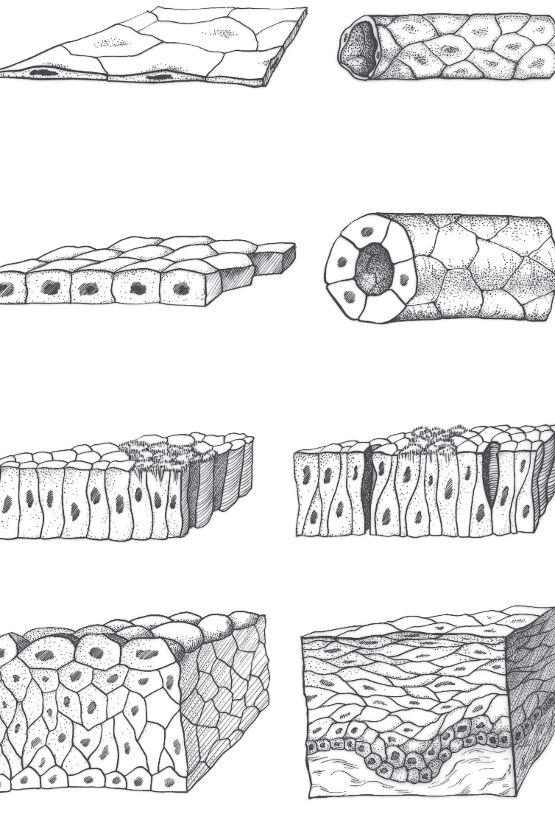
Primary types of epithelial tissues. A) Simple squamous. B) Simple squamous in tubular arrangement. C) Simple cuboidal. D) Simple cuboidal arranged as a duct. E) Simple columnar. F) Pseudostratifi ed columnar with cilia. G) Transitional. H) Stratifi ed squamous.

GLANDS
Glandular epithelial cells are specialized for secretion or excretion. Secretion is the release from the gland cell of a substance that has been synthesized by the cell and that usually affects other cells in other parts of the body. Excretion is the expulsion of waste products.
Glands may be classified either as endocrine glands or as exocrine glands (glands that empty their secretory products on an epithelial surface, usually by means of ducts).
Types of Gland:
The two types are based on the mechanism of their secretion.
1) Exocrine Glands – Glands that secrete their products onto the apical (or epithelia) surface directly OR via epithelial ducts or tubes that are connected to the apical surface. These exocrine glands are composed of highly specialized epithelial cells and thus are classified as glandular epithelia
2) Endocrine Glands - Glands that release their products basally, so the secretion goes through the basal lamina, moves into the underlying connective tissue, and enters the vascular system. Endocrine glands lack a duct system.
a) Paracrine Glands – These glands are similar to endocrine glands, but their secretions reach target cells by diffusion through the extracellular space or immediately subjacent connective tissue. These secretory products are not delivered to their target tissue via ducts or the bloodstream.
Classification of Glandular Epithelia: This classification system is based on five different morphological criteria.
1) Number of secretory cells
a) Unicellular glands – Mucus-secreting goblet cells are the only example of these single-celled glands. Found in humans. These goblet cells secrete mucus and are easily visualized in slides of the small intestine. In routine (H&E) preparations, the cytoplasmic mucin is not preserved (and therefore, not stained) giving the cells an empty appearance. The mucus is not preserved The unicellular Goblet cells are best seen in Periodic Acid Schiff (PAS) staining.
b) Multicellular glands - These glands have many cells. In addition to the ways that multicellular glands are classified (listed below), they may also form a secretory sheet of epithelial cells like the linings of the stomach and the uterus.
2) Nature of secretion
a) Serous – A cell-type that produces a thin watery, protein-rich secretion (e.g. the pancreas and parotid salivary glands are entirely serous in nature).
b) Mucous – A cell type that is characterized by numerous large, lightly staining granules containing strongly hydrophilic glycoproteins called mucins, viscous secretions that have a lubricating or protective function.
c) Mixed – These glands have both serous and mucous cells.
3) Mechanism of secretion (the way in which the secretory products leave the cell) – The three mechanisms by which secretions for exocrine glands are extruded are merocrine, apocrine, or holocrine secretions.
a) Merocrine secretion (aka eccrine secretion) - This is the most common type of glandular epithelium secretion where. secretory granules within the cytoplasm of the cell gather at the apical region of the cell. Then, the granule’s limiting membrane fuses with the apical membrane and the contents of the granule are opened and released. This process of fusion and release are collectively referred to as exocytosis. The secretory granules leave the cell with no loss of other cellular material. Mucous and serous cells exhibit this type of secretion.
b) Apocrine secretion – A rare type of secretion dependent on sex hormones where secretory granules within the cytoplasm gather at the apical region of the cell. Then, a portion of the cytoplasm of the cell simply pinches off enclosing the granules. Within the lumen, this small secretory vesicle breaks down and releases the gland’s products.
Examples of apocrine glands include lactating mammary glands, apocrine glands of skin in the pubic and axilla regions, ciliary (Moll’s) glands of the eyelid, and the. ceruminous glands of the external acoustic meatus.
c) Holocrine secretion – This secretion consists of disintegrated cells of the gland itself. Granules fill the cell until the entire cell becomes “bloated” with secretory products. Instead of being released (merocrine) or pinched off (apocrine), the whole cell is discharged into the lumen. Once inside the lumen, the cell degenerates and the secretory products are released.
This type of secretion occurs primarily in sebaceous glands within the skin, but also in the tarsal (Meibomian) glands of the eyelid.
4) Shape of Secretory Units – exocrine glands have a secretory portion, which contains the cells responsible for the secretory process, and ducts, which transport the secretion to the exterior of the gland.
a) Tubular - An elongated group of secretory cells with a tube-shaped lumen. Mucous cells are most often organized as tubules, consisting of cylindrical arrays of secretory cells surrounding a lumen.
b) Acinar (or alveolar) - A small grape-like (acinus means “grape”) or sac- like (alveolus means “sac”) group of secretory cells arranged about a small lumen. These cells, as they are in other glandular units, are attached to a basement membrane.
c) Tubulo-aveolar- Lumen of secretory units have both of the above listed shapes
5) Arrangement (branched or not) and Occurrence of Duct System
a) Simple glands - Glands that have an unbranched duct into which the cells secrete. Each secretory portion empties separately on an epithelial surface.
b) Compound glands - These glands have a highly branched duct system. Secretory portions empty into an elaborate branched duct system, which, in turn, drain into larger ducts. They grossly divide into lobes which may further divide into lobules, hence a connective tissue called the septa and subsequent interlobar septa
Types of Exocrine Glands
1) Simple tubular glands - These glands are epithelial-lined tubules, which open on the apical surface. There are three types.
a) Simple straight tubular glands - The long crypts of Lieberkühn, located within the colon, are a great representation of tubular glands that runs a straight, unbranched course.
b) Simple coiled tubular glands - Within the dermis, eccrine sweat glands are located. The deeper portion of these simple coiled tubular glands is easily seen; however, the long unbranched lumen that goes to the apical surface is rarely seen in cross-section.
c) Simple branched tubular glands - These simple branched tubular glands are found primarily in the stomach
2) Simple alveolar (acinar) glands - The best representation of simple alveolar glands is the paraurethral glands located in the penile urethra or the sebaceous glands located in the skin.
3) Simple tubular-alveolar glands - Some of the secretory cells are arranged as acini (alveoli) and others are arranged as tubules. Examples of these include some of the smaller glands of the respiratory tract; minor salivary glands located within the oral cavity
4) Compound tubular glands - These glands have a highly branched duct system. The secretory cells at the ends of the ducts are in the form of tubules. Brunner’s glands of the duodenum are compound tubular glands.
5) Compound alveolar glands - The duct system is similar to the compound tubular and compound tubulo-alveolar glands; however, compound alveolar glands differ from other compound glands in that the ducts end in alveoli with dilated sac-like lumina. The pancreas and parotid gland
6) Compound tubulo-alveolar glands - These glands also have a highly branched duct system, but some of the ducts end as tubules and others end as alveoli. Two of the major salivary glands, the submandibular and the sublingual glands,

Function of Epithelium: Examples:
1) Mechanical protection - skin or in body tubes (stratified squamous)
2) Permeability barrier - cells lining the GI tract regulates what enters BVs
(selective) (simple columnar cells of small intestine)
3) Absorption - small intestine (simple columnar)
4) Filtration - epithelium of renal corpuscle (simple squamous)
5) Secretion - glandular epithelium (simple cuboidal in ducts)
6) Diffusion of gases or fluids - lung alveoli or blood vessels (simple squamous)
7) Surface transport over epithelium - respiratory tract (pseudostratified columnar ciliated) or oviduct (simple columnar ciliated)
8) Sensory - epithelium often specialized among sense organs
Connective Tissues
Connective tissues, as the name implies, serve to connect other tissues. They give form and strength to many organs and often provide protection and leverage. Connective tissues include elastic tissue, collagenous (white fibrous) tissue, reticular tissue, adipose (fat) tissue, cartilage, and bone.

Types of connective tissue
a) Loose connective tissue
Reticular connective tissue;
They consists of fine fibrils and cells. Reticular tissue makes up part of the framework of endocrine and lymphatic organs.
Adipose tissue (fat)
They forms when connective tissue cells called adipocytes store fat as inclusions within the cytoplasm of the cell. Most fat in the animal body is white, although it may have a yellow tinge in horses and some breeds of dairy cattle because of carotenoids in the feed. In contrast to this white fat, a small amount of brown fat may be found in domestic mammals, hibernating mammals, rodents, and human infants. Brown fat apparently generates heat to protect young mammals and hibernating mammals from extreme cold

Elastic tissue contains fibers that tend to regain their original shape after being stretched. This tissue is found in the ligamentum nuchae, a strong band that helps to support the head, particularly in horses and cattle. Elastic tissue also is found in the abdominal tunic, in elastic arteries, and mixed with other tissues wherever elasticity is needed.

(b)Dense connective tissue
Dense regular connective tissue; the fibers are arranged in parallel bundles forming cords or bands of considerable strength. They form tendons, which are connective tissues that connect muscles to bones and also the ligaments which are connective tissues that connect bones to bones.
Dense irregular connective tissue; the fibres are arranged in a thick mat, with fibers Running in all directions. The dermis of the skin, which may be tanned to make leather, consists of dense irregular connective tissue. blood vessels are surrounded by a sheath of areolar connective tissue, which permits the vessels to move and yet protects them.

(c) Cartilage, this is a special type of connective tissue that is firmer than fibrous tissue but not as hard as bone. They are formed from chondrocytes or cartilage cells. The three types of cartilage described are hyaline, elastic, and fibrous.

Hyaline cartilage is the glasslike covering of bones within joints. This type of cartilage forms a smooth surface that reduces friction, so that one bone easily glides over another. The actively growing areas near the ends of long bones also consist of hyaline cartilage.
Elastic cartilage consists of a mixture of cartilage substance and elastic fibers. This type of cartilage gives shape and rigidity to the external ear.
Fibro-cartilage consists of a mixture of cartilage and collagenous fibers, which forms a semi-elastic cushion of great strength. The intervertebral disks between the bodies of adjacent vertebrae are composed of fibro-cartilage.

Bones
Bone is produced by bone-forming cells called osteoblasts. These cells produce osteoid tissue, which later becomes calcified to form bone. The bone may be arranged in the form of spicules (small spikes) and flat plates, forming a spongelike network called cancellous bone or spongy bone. Alternatively, it may be laid down in the form of laminated cylinders (Haversian or osteonal systems), closely packed together to form compact bone

BLOOD

Blood consists of a fluid matrix (liquid portion), the plasma, a variety of cells, proteins, monosaccharides (simple sugars), products of fat degradation, and other circulating nutrients, wastes, electrolytes, and chemical intermediates of cellular metabolism.

Red blood cells (RBCs) are also called erythrocytes.
In most domestic mammals they are non-nucleated biconcave disks that contain the protein hemoglobin. The main function of the RBCs is to carry hemoglobin. Hemoglobin in turn has the primary function of carrying oxygen from the lungs to all tissues of the animal. At the tissue level, oxygen is released to the cells, while carbon dioxide, which is produced by the cells, diffuses into the blood to be carried back to the lungs, where it can be eliminated during breathing. Anemia is the deficiency of functional RBCs in the blood. It can result from a loss of red cells (as in hemorrhage), insufficient RBC production, or inappropriate or premature degradation of the red cells. Polycythermia is the presence above normal the number of functional rbcs in the blood.

White cells (also called leukocytes) are one of the body’s first lines of defense against infection. They are grouped into 2; agranulocytes and granulocytes.
i). Agranulocytes are of two kinds:
(a )monocytes, large cells that engulf and destroy foreign particles, and
(b) lymphocytes, which usually are smaller and are associated with immune responses. Basically grouped into ;
** ‘T’ cells which are responsible for cellular immunity. They may be the cytotoxic ‘T’ cells r the helper ‘T’ cell. They are for coordination of immune responses.
** ‘B’ cells which are responsible for humoral immunity and distribution of antibodies that attack foreign antigens throughout the body
** ‘NK’ cells; found mostly in humans. It is responsible for immune surveillance detection and destruction of abnormal cells. Important in cancer prevention
ii). Granulocytes which are also known as polymorphonuclear leukocytes
are of three types;
a) neutrophils; granules are chemically neutral which makes them difficult to stain with both acidic and basic dyes.
b) basophils; their granules stain dark with basic dye. They are smaller than neutrophils and eosinophils.
c). eosinophils; granules stain dark with eosin (red) dye.

Blood platelets (thrombocytes) are small, irregularly shaped cellular fragments that are associated with the clotting of the blood. Mammalian platelets lack a nucleus.
Plasma is the fluid part of unclotted blood. Plasma is particularly useful as a substitute for blood in transfusions because the proteins in it give it the same osmotic pressure as blood. Plasma therefore will not escape from blood vessels as readily as a salt solution.
Serum is the supernatant fluid that remains after a clot forms and incorporates the cellular components of blood. It is similar to plasma but lacks most of the clotting factors.
Functions of the blood:
*transportation of dissolved gases, nutrients, hormones, & metabolic wastes
*regulation of pH & electrolyte composition of interstitial fluids throughout body
*blood absorbs & neutralizes acids generated by active tissues
*needs to get rid of protons
*restriction of fluid losses through damaged vessels or at other injury sites
*defense against toxins & pathogens
*stabilization of body temperature
blood smear: thin film of capillary blood on surface of microscope slide; can be stained with
special dyes to show different types of formed elements
*arterial puncture: arterial stick; may be used for checking efficiency of gas exchange at lungs
*whole blood, taken from any source, has same general characteristics:
*temperature – 38 C
*viscosity – 5 times stickier, more cohesive, & resistant to flow than water
*pH – averaging 7.4 – slightly alkaline
*hypovolemic: low blood volume
*normovolemic: normal blood volume
*hypervolemic: high blood volume

Muscle Tissue
There are two types of muscle tissue; Smooth and striated muscle. The striated muscles are further divided into skeletal and cardiac muscles. Both skeletal and cardiac muscle cells consist of fibers that under the microscope show characteristic cross-striations. Each skeletal muscle cell must have its own nerve supply, and when stimulated, the whole fiber contracts. This is the all-or-nothing law of muscle contraction. However, the force of contraction depends on the state of the fiber at any one moment. For example, is it already fatigued? Is it warmed up? Is it stretched? Striated skeletal muscle tissue plus some connective tissue makes up the flesh of meat-producing animals.

Smooth muscle cells are spindle-shaped cells that contain one centrally located nucleus per cell. Smooth muscle is found in the walls of the digestive tract, in the walls of blood vessels, and in the walls of urinary and reproductive organs. These cells contract more slowly than skeletal muscle and in response to a variety of stimuli. They are not under voluntary control

Cardiac muscle is also known as involuntary striated muscle because it is not usually under conscious control, yet it does have cross-striations. Modified muscle cells called Purkinje fibers conduct impulses within the heart, much as nerve fibers do in other parts of the body.

Nervous Tissue
They primarily comprise of cells of the central nervous system and peripheral nervous system. The CNS consist of neural tissues which form the brain and the spinal cord plus the retina. The PNS consists of the cranial nerve and the spinal nerve as well as the motor neurons .
The essential cell of nervous tissue is the neuron or nerve cell. The neuron consists of a nerve cell body and two or more nerve processes or fibers.
axons; they are fibers that conduct impulses away from the cell body.
Dendrites; they are fibers that conduct impulses toward the cell body
Tracts; Bundles of axons in the spinal cord and those in the periphery are called nerves. A nerve fiber may be covered by a myelin sheath which is a specialized wrapping created by supportive cells called Schwann cells in nerves or by oligodendrocytes within the brain and spinal
Overview of the animal body
All farm animals are vertebrates, and as such they have a vertebral column. The body (with the exception of some of the internal organ (The tongue, trachea, vertebral column, and hearts etc) exhibits bilateral symmetry.The diaphragm divides the embryonic body cavity into a thoracic cavity and the abdominopelvic cavity. Each of these are further subdivided. The thoracic cavity contains the pericardial sac, which surrounds the heart, and two pleural sacs, which surround the two lungs. The abdominopelvic cavity is somewhat arbitrarily divided into the abdominal and pelvic cavities. The abdominal cavity contains the kidneys, most of the digestive organs, and a variable amount of the internal reproductive organs in both sexes. The pelvic cavity contains the terminal part of the digestive system (the rectum) and all of the internal portions of the uro-genital system not found in the abdominal cavity. The serous membrane that surrounds the abdominal viscera and part of the pelvic viscera is called peritoneum

DIGESTIVE SYSTEMS
Digestion; this is a process that involves the prehension of food (to take food into mouth),mastication ( the mechanical chewing and grinding), deglutition( swallowing), its mixing with digestive acid and enzymes to chemically break down feedstuffs and its absorption ( transportation of digested food across the intestinal mucosa or the lymphatic system). The system is made up of the gastro-intestinal tract and accessory organs.

Farm animals can be categorized based on their feeding pattern;
- Carnivorous; they are animals that consume flesh of other animals. They have well developed stomach, limited fibre digestion and possess uncomplicated intestine. Example; dogs and cats
- Omnivore; they are animals that consume both plants and flesh. They have a more complicated GIT than carnivore. They are cecal digester (rats) or colonic digester (primates, pigs).
- Herbivore; they are animals that consume plant material. E.g. horses, cattle and rabbit. Each has a different type of GIT Horse- simple stomach, large cecum, large sacculated LI. Rabbit- larger stomach, very large sacculated cecum, unsacculated LI. Cattle – ruminant.
Farm animals have a variety of digestive systems
  - Ruminants: have 4 different compartments to the stomach
    - Examples include cattle, sheep, goats
  - Non ruminants (also known as monogastrics)
    - pigs, dogs, and cats have a single, simple stomach
    - Poultry have a two part stomach
    - Horses have a large, functional cecum
The digestive system is made up of the gastro-intestinal tract and the accessory organs. They include; mouth, salivary glands, esophagus, liver, gall bladder, stomach, pancreas, small intestine, large intestine, rectum.

Functions of the gastro-intestinal tract;
*. Motility: movement through the GI tract
*. Digestion: breakdown of food or chyme
*. Secretion and absorption: across and epithelial layer either into the GI tract (secretion) or into blood (absorption)
*. Storage and elimination

* Digestive waste could be essential in diagnosis of certain disease conditions as coccidiosis, new castle disease etc.

The mouth
The mouth is the first part of the digestive tract. The tongue and the teeth are found in the mouth. The inside of the mouth is lubricated with saliva that comes from the salivary glands, and other minor glands in the mouth as Buccal gland and labial gland
Teeth
Tooth (plural; teeth) is a small, calcified, whitish structure found in the oral cavity ( buccal cavity/ mouths) of many vertebrates and used to break down food. Some animals, particularly carnivores, also use teeth for hunting or for defensive purposes. The roots of teeth are covered by gums. Teeth are not made of bone, but rather of multiple tissues of varying density and hardness. The cellular tissues that ultimately become teeth originate from the embryonic germ layer, the ectoderm. The shape of the animal's teeth is related to its diet. For example, plant matter is hard to digest, so herbivores have many molars for chewing and grinding. Carnivores, on the other hand, need canines to kill prey and to tear meat. Mammals in general are diphyodont, (meaning that they develop two sets of teeth) . In humans, the first set (the "baby," "milk," "primary" or "deciduous" set) normally starts to appear at about six months of age, although some babies are born with one or more visible teeth, known as neonatal teeth .Kangaroos, elephants and manatees are unusual among mammals because they are polyphyodonts. Some animals develop only one set of teeth monophyodont while others develop many sets (polyphyodont). Sharks, for example, grow a new set of teeth every two weeks to replace worn teeth. Rodent incisors grow and wear away continually through gnawing, which helps maintain relatively constant length. Many rodents such as voles (but not mice) and guinea pigs, as well as leporidae like rabbits, have continuously growing molars in addition to incisors.
There are four types of teeth in the mouth. The incisor, canine, premolar and molar
Function of the teeth
the incisors are used in cutting food. The canines are used for grasping, piercing and tearing. The premolars and molars are used for crushing and grinding, aging of farm animals.
Dentition < I; incisor, C canine, P premolar, M molar

Horse; I 3/3 C 1/1 P 3/3 or 4/4 M 3/3 =40 or42

Goat/sheep; I 0/3 C 0/1 P 3/3 M 3/3= 32

Cattle/buffalo; I 0/3 C 0/1 P 3/3 M 3/3 or 0/4 or 0/0=32

Canine; I 3/3 C 1/1 P 4/4 M 2/3=42

Salivary gland
They are exocrine glands found in the mouth that produce saliva.
Function of the salivary gland
- Saliva from these glands lubricates the food and makes it soft.
- Saliva also contains an enzyme that breaks down starch, antimicrobial agents, and amylase to digest starch.
- Thermoregulation <dogs; panting, cats; grooming>
- Saliva prevents degeneration of teeth and soft tissues of the oral cavity
Salivary glands include; parotid, sublingual and sub-mandibular and the zygomatic salivary gland found in the dog. It should be noted that the saliva of horses do not contain enzyme.
Factors affecting saliva production;
- Health status of animal.
- Diet composition; fibre increases chewing thereby promoting increased saliva outflow.
- Feed moisture content
- Feed intake; increase feed intake causes increased saliva flow.
Esophagus
From the mouth, food goes down the esophagus through the pharynx or throat. The esophagus is a muscular tube that can open and close at the pharynx. It can also open and close to the stomach. The walls of the esophagus consist of smooth muscles. The wavelike movement of these muscles, called peristalsis, pushes the food down to the stomach. Contraction occurs behind the bolus of food and relaxation occurs ahead of the bolus of food. Epiglottis covers respiratory tract during swallowing. At end of esophagus is the lower esophageal sphincter (LES). It is also important for regurgitation (the backward flow of food through the esophagus)
Stomach
Non ruminant or the Monogastric stomach
The stomach is a hollow muscular organ shaped like a bag. Its upper end is connected to the esophagus while the lower end is connected to the small intestine. The upper and lower ends of the stomach have smooth circular muscles called sphincter muscles. When the upper end muscle relaxes, the stomach open sand food gets in. when the lower end muscles relaxes, partially digested food moves out of the stomach. The sphincter muscles keep the food in the stomach. The stomach is flexible and can expand when you eat. It can hold from 1 to 3 liters of food. The stomach acts as a storage bag of food. The stomach contains three layers of smooth muscles which also produce peristaltic movements to continue breaking down the food.
Functions:
1. store food
2. Initiate digestion of proteins
3. Kill bacteria with the strong acidity of the digestive juice (the gastric juice( hydrochloric acid) low pH of about 2 )
4. Makes chyme ( material passed from the stomach to the small intestine )
5. Secretion of gastric juice
Parts of the stomach:
- Cardia; this is where the content of the esophagus empties into the stomach
(b) Fundus; formed by the upper curvature of the organ
(c) Body; this is the main or central region. It is also known as the corpus.
(d) Pyloric region (pyloric sphincter); also the pylorus. This is the lower section that facilitates emptying of the contents into the duodenum (small intestine)
Ruminant stomach
The primary difference between a ruminant and non-ruminant (called monogastrics, such as humans, dogs, and pigs) is that ruminants have a four-compartment stomach. The four parts of the stomach are;
a. rumen; - large fermentation vat; also called the "paunch” . Anaerobic in nature, Temperature = 39ºC (103ºF), saturated with gasses and in constant motion. The rumen house micro-organisms that make vitamin k and b complexes.
b. Reticulum; it has a honeycomb appearance, houses microorganisms like the rumen, catches hardware (ingested by animal e.g. nail) and houses the opening to the omasum.
Even though the rumen and reticulum have different names they represent the same functional space as digesta can move back and forth between them. Together these chambers are called the reticulorumen.
c. Omasum; it has the manyplies“ or “book” appearance. full of folded tissue . water absorption absorption takes place here.
d. Abomasum; . The abomasums also known as the true stomach is the direct equivalent of the monogastric stomach (for example that of the human or pig).
In the first two chambers, the rumen and the reticulum, the food is mixed with saliva and separates into layers of solid and liquid material. Solids clump together to form the cud or bolus.
The cud is then regurgitated and chewed to completely mix it with saliva and to break down the particle size. Fiber, especially cellulose and hemi-cellulose, is primarily broken down into the three volatile fatty acids (VFAs); acetic acid, propanoic acid and beta-hydroxybutyric acid , in these chambers by microbes (mostly bacteria and well as some protozoa , fungi and yeast ). Protein and non-structural carbohydrate (pectin, sugars, starch ) are also fermented.
The degraded digesta, which is now in the lower liquid part of the reticulorumen, then passes into the next chamber, the omasum, where water and many of the inorganic mineral elements are absorbed into the blood stream. After this the digesta is moved to the true stomach, the abomasum. The abomasum is the direct equivalent of the monogastric stomach (for example that of the human or pig), and digesta is digested here in much the same way. Digesta is finally moved into the small intestine, where the digestion and absorption of nutrients occurs. Microbes produced in the reticulorumen are also digested in the small intestine. Fermentation continues in the large intestine in the same way as in the reticulorumen.
Only small amounts of glucose are absorbed from dietary carbohydrates. Most dietary carbohydrates are fermented into VFAs in the rumen. The glucose needed as energy for the brain and for lactose and milk fat in milk production, as well as other uses, comes from non-sugar sources such as the VFA propionate, glycerol, lactate and protein. The VFA propionate is used for around 70% of the glucose and glycogen produced and protein for another 20% (50% under starvation conditions).
Cells and Secretions of the stomach
The stomach is known for secretion of various products by its epithelial cells, all of which are vital either to the digestive process or the control of gastric functions. They include;
- Parietal ( oxyntic ) cells
They produce hydrochloric acid. This acid secretion lowers the stomach ph. It initiates protein digestion and also kills pathogenic bacteria in ingested food.
- Chief (zymogenic) cells
They secrete pepsinogen ( protease). Pepsinogen, an inactive zymogen, is secreted into gastric juice from chief cells. Once secreted, pepsinogen is activated by stomach acid into the active protease pepsin.
- Goblet cell or the mucus cell
These cells secrete mucus which protects the mucosa of the stomach wall (simple columnar epithelium) from the action of acid and digestive enzymes. Malfunctioning of this cell leads to ulcer.
Other cells that can be found in the stomach include; enterchromaffin like cells which secrete histamine and serotonin. The D-cells that produce somatostatin, and G cells that produce gastrin.
Small Intestines
Found below the stomach and liver. They form the major part of the digestive tract. Their walls are made of smooth muscles. The inner lining of the small intestines is folded into tiny fingerlike projections called villi (singular, villus). Each villus contains blood vessels. The work of the small intestines is to digest food, which can then be absorbed by the blood. The villi act much like the same as the folded towels. Because the wall of the intestine is folded into millions of villi, the surface area through which nutrients pass to the bloodstream is greatly increased.
Small intestine starts from the pyloric sphincter to the ileocecal valve.12ft in length, small in diameter compared to large intestine and composed of the columnar epithelial cells.
Section of the small intestine;
1. Duodenum: First and Shortest section of the SI with a ph of 6.0-6.5 and ends where the jejunum starts.. this is the Active Digestion Site , Absorption of carbohydrates, lipids, amino acids, Ca 2+, iron and also where enzymes produced by the pancreas, liver and duodenal wall are emptied into digestive tract. Duodenal wall secretions/Enzymes include;
Maltase and Sucrase for CHO digestion, Lactase, Aminopeptidase, Dipeptidase which helps in protein digestion.
2. Jejunum: this is the middle section of the small intestine. It lays between the duodenum and the ileum. It specializes in the absorption of small nutrient (carbohydrates, lipids, amino acids, Ca 2+, iron) which has been previously digested by enzymes in the duodenum.
3. Ileum: this is the final section of the small intestine. There is absorption of bile salts, vitamin B12, water electrolytes. Its separated from the cecum by the ileocecal valve the wall is made up of folds which has villi on its surface which in turn possess even larger number of microvilli. Therefore the ileum has large surface area both for absorption of enzymes molecule and absorption of products of digestion
Note; there is no marked difference between the jejunum and ileum. There are however subtle differences; presence of the lymphoid tissue: payer’s patches.
Absorption in Small intestine is by
1. Passive diffusion; diffusion from high to low concentration e.g. minerals, water
2. Facilitated diffusion; from high to low concentration but use carrier proteins in intestinal surface e.g. vitamins.
3. Active absorption; :- from low to high concentration requires energy and specific carrier proteins e.g. Glucose and amino acids.
Large intestine
This is the last part of the digestive system in vertebrate. Large intestine is from the ileocecal valve to the anus. The work of the large intestine is to absorb water from the undigested food, hold the undigested food for a while and then excrete it as feces. It is a Fermentation site.
Functions include;
- bacterial protein and cellulose breakdown
- VFA production
- Water Soluble Vitamin production
D. absorption of vitamins (B and K)
E. produces small fatty acids used as energy by GI epithelial cells
F. help breakdown indigestible molecule
Microscopically, it is made up of columnar epithelial cells, goblet cells, scattered lymphocytes, lymphathic nodules and contains no villi. It comprises of 3 sections; cecum, colon and rectum
Cecum; this is the beginning of the large intestine and extends from the ileum separated by the ileocecal valve to the colon. it Contains active bacteria similar to rumen bacteria.
Colon; this part commences where the cecum ends and stops at the rectum. In mammals, it consists of the ascending, transverse, descending colon. It’s a site for storage and water absorption (also some fat and minerals absorption). No absorption of amino acids and sugars.
Rectum; this is the final portion of the large intestine and opens into the anus through which useless fecal material are removed.

Accessory organs of the digestive system
Liver
This is the largest organ ( second to the skin) and also the largest gland. It is reddish brown in color, located below the diaphragm, right to the stomach and overlies the gall bladder. Liver cells are called the hepatocytes.
The liver (hepar) is an extremely important organ in the body of mammals and vertebrates as it provides functions essential for life. It is the largest internal organ and has numerous functions including production of bile and protein, fat and carbohydrate metabolism. During foetal development, the liver has an important haemopoetic function, producing red and white blood cells from tissue between the hepatic cells and vessel walls. The liver is located in the cranial part of the abdomen. It is immediately caudal to the diaphragm and cranial to the stomach and intestines. Generally the bulk of the liver is on the right of the midline. It is divided into lobes by fissures. The lobes of the liver include the left lateral, left medial, right lateral, right medial, quadrate, caudate and papillary.
The liver has a dual blood supply. 70-80% via the hepatic portal vein (nutrient rich) and 20-30% via the hepatic artery (oxygen rich). It has a large blood supply (nearly a 1/3 of cardiac output passes through the liver).The hepatic artery is a branch of the caeliac artery. The portal veinis formed by tributaries draining the spleen, pancreas and digestive tract. Intrahepatic arteries combine with portal vein branches to supply the connective tissue and hepatic sinusoids of the liver. Blood flows from the portal areas into the central vein. The central vein is lined by simple squamous epithelium. The bile duct, blood vessels (including the important hepatic vein) and nerves enter and leave the liver at the hepatic porta. Blood from the central vein opens into the caudal vena cava
Functions of the liver
- Urea formation
- Detoxification of harmful compounds.
- Storage of carbohydrate (glycogen), vitamins and minerals.
- Synthesis of glucose. Responsible for gluconeogenesis( synthesis of glucose from amino acids.), glycogenolysis( breakdown of glycogen into glucose), glycogenesis( formation of glycogen from gluucose).
- Synthesis of cholesterol and triglycerides.
- Synthesis and degradation of amino acids.
- Production of coagulation factors.
- Bile synthesis.
Note; Enterohepatic circulation: from liver via bile duct to small intestine and then from small intestine back through portal vein to liver. Liver clears substances via the bile duct in a similar manner to the way the kidney clears substances into the nephron.
Gall bladder
The gall bladder is a small muscular sac that is attached beneath the liver. Bile produced by the liver passes through a small tube and is stored in the gall bladder. From the gall bladder, bile is released to the small intestine digestion. The bile aids in the emulsification of fat and it also activates pancreatic lipase enzyme.
Pancreas
The pancreas is an organ that lies behind the stomach. Its function related to digestion is to produce pancreatic juice. Pancreatic juice helps in neutralizing or weakening the acid in food inside the stomach before it moves onto the small intestine. It assists in carbohydrate, protein and lipid digestion. Pancreas secretion enters the duodenum via pancreatic duct.
Pancreatic secretions include;
A. digestive enzymes; they include amylase which helps in the digestion of starch, trypsin , chymotrypsin, carboxypeptidase, nuclease which helps in protein digestion. Lipases which digest lipids and cholesterol-esterase which digests cholesterol.
B. bicarbonate ( buffer); they neutralize the ph of the small intestine.
C. hormones; they include insulin and glucagon. They Play a role in glucose metabolism.

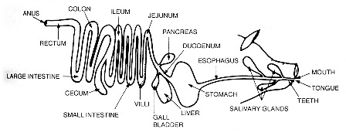
Digestive tract of a monogastric
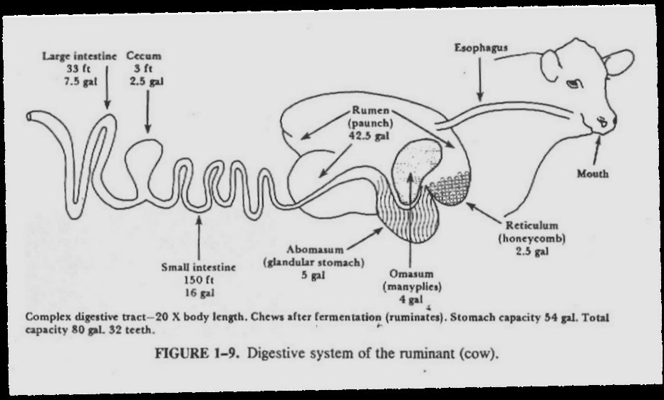

Avian digestive system

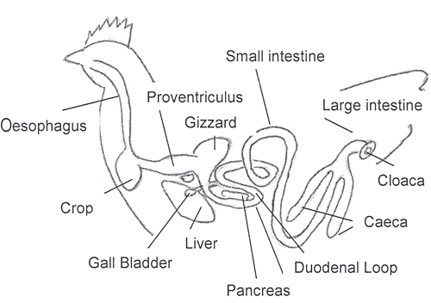

The avian's digestive system breaks down ingested food to basic components by mechanical and chemical means. These basic components are then absorbed and used throughout the body. A knowledge of the digestive process greatly assists in understanding the nutritive requirements of the avian species.
The digestive system begins at the mouth and ends at the cloaca. Intervening organs/parts include the esophagus, crop, proventriculus, gizzard, duodenum, small intestine, paired caeca and large intestine. Other organs vital to digestion are the liver and pancreas.

Mouth
Most birds, obtain feed with the use of their beak. Food picked up by the beak enters the mouth. As previously mentioned, chickens do not have teeth so they are not able to chew their food. The mouth does contain glands which secrete saliva which wets the feed to make it easier to swallow. The saliva also contains some enzymes which start the digestion of the food eaten. The chicken’s tongue is then used to push the feed to the back of the mouth so that .it can be swallowed.
Esophagus:
The esophagus is a flexible tube that connects the mouth with the rest of the digestive tract. It carries food from the mouth to the crop and from the crop to the proventriculus.

Crop:
The crop is an out-pocketing of the esophagus and is located just outside the body cavity in the neck region.it is a temporary storage Any swallowed feed and water is stored in the crop until it is time to pass it on to the rest of the digestive tract. When the crop is empty, or nearly empty, it sends hunger signals to the brain so that the chicken will eat more.

Proventriculus:
The esophagus continues past the crop to connect the crop to the proventriculus. The proventriculus (also known as the ‘true stomach’) is the glandular stomach where digestion begins. As with human stomachs, hydrochloric acid and digestive enzymes (e.g., pepsin) are added to the feed here and digestion begins. At this point, however,
the food has not yet been ground up. The term ‘proventriculus’ is used since it comes before the ‘ventriculus’ or gizzard, with ‘pro’ being a Latin terming meaning before.
Gizzard / Ventriculus: The gizzard, or ventriculus, is a part of the digestive tract unique to birds. It is often referred to as the ‘mechanical stomach’. It is made up of two sets of strong muscles which act as the bird’s teeth (see Figure 4 above). Consumed feed and the digestive juices from the salivary glands and the proventriculus pass into the gizzard for grinding, mixing, and mashing.

Small intestine:
The small intestine is made up of the duodenum (also referred to as the duodenal loop) and the lower small intestine. The duodenum receives digestive enzymes and bicarbonate (to counter the hydrochloric acid from the proventriculus) from the pancreas and bile from the liver via the gall bladder. The digestive enzymes produced by the pancreas are primarily involved in protein digestion. Bile is a detergent that is important in the digestion of lipids and absorption of fat soluble vitamins (vitamins A, D, E and K). The remainder of the digestion occurs in the duodenum and the released nutrients are absorbed mainly in the lower small intestine. The lower small intestine is composed of two parts, the jejunum and ileum. The Merkel’s Diverticulum marks the end of the jejunum and the start of the ileum.
Note; In the developing embryo the yolk sac supplies the nutrients needed for it to develop and grow. Right before hatch, the yolk sac is taken into the navel cavity of the embryo. The residual tiny sac is the Merkel’s Diverticulum The material remaining in the yolk immediately after hatch is able to supply the feed and water needs of the newly hatched chicken. This is why it is possible to ship chicks long distances without adverse affects\

Ceca (plural form; singular = cecum):
The ceca are two blind pouches located where the small and large intestines join. Some of the water remaining in the fecal material is reabsorbed here. Another important function of the ceca is the fermentation of any remaining coarse materials. In doing so they produce several fatty acids as well as the eight B vitamins (Thiamine, riboflavin, niacin, pantothenic acid, pyridoxine, biotin, folic acid and vitamin B12). Because the ceca are located so close to the end of the digestive tract, however, very little of the produced nutrients are absorbed and available to the chicken. The ceca empty their contents two or three times a day, producing pasty droppings that often smell worse than regular droppings. Cecal droppings typically have a mustard to dark brown in color. The number of times cecal droppings are ‘pooped’, as well as their color and texture, tell you that the chicken’s digestive tract is functionally normally.

Large intestine (also known as the colon): Despite the name, the large intestine is actually shorter than the small intestine in poultry. The large intestine is where the last of the water reabsorption occurs.
Cloaca:
In the cloaca there is a mixing of the digestive wastes together with wastes from the urinary system (urates). Fecal material is usually voided as digestive waste with white uric acid crystals on the outer surface (i.e., chickens do not urinate/pee). The reproductive tract also exits through this area but when a hen lays an egg the vagina folds over to allow the egg to leave through the vent without coming into contact with the feces or urine. The color and texture of chicken fecal material can indicate the health status of the chicken’s digestive tract. The white pasty material that commonly coats chicken fecal material is uric acid, the avian form of urine, and is normal.

Appearance of Feces
Droppings with blood = coccidiosis
Greenish droppings = late stages of worms (or has eaten a lot of green vegetables if free-ranged)
White, milky runny droppings = worms, coccidiosis, Gumboro disease (Infectious Bursal Disease)
Brown runny droppings = E. coli infection
Clear or watery runny droppings = stress, Infectious Bronchitis
Yellow & foamy droppings = coccidiosis.
Grayish white & running continuously = vent gleet (a chronic disease of the cloaca of domestic birds.
Species variations
Salivary gland
Absence of salivary enzyme ( amylase) in horses. All mammals have 3 salivary glands except the dog that has the 4th called the zygomatic salivary gland
Esophagus
Horses, monogastrics, rabbits do not regurgitate. Only ruminants do. In poultry, the esophagus connects the mouth to the crop and also from crop to the proventiculus.
Stomach
Ruminants; presence of 4 compartment stomach.
Monogastrics ;( horses, rabbits, pigs). They possess a simple stomach.
Poultry; birds have 2 compartment stomach comprising of the proventriculus and gizzard.
Cecum; poultry possess 2 ceca.
Gall bladder; absent in horses.
Carbohydrate digestion
CHO digestion in monogastrics occurs in the mouth, stomach and small intestine. CHO as starches are acted upon by the salivary amylase in the mouth converting it to maltose. The pancreatic amylase and the intestinal amylase also continue this process until the starch is converted to maltose and iso-maltose. Lactose is acted upon my lactase to give galactose and glucose. Sucrose act on sucrose to produce fructose band glucose. These end products are the absorbable forms of carbohydrate contained in foods.
Digestion in the ruminant ( discussed earlier)
Protein digestion.
Protein digestion occurs in the small intestinal(duodenum) although hydrolysis of protein by pepsin begins in the stomach. Protein digestion in ruminant is essentially a fermentation process. Dietary protein is acted upon by proteolytic enzymes in rumen giving rise to amino acids. Some are quickly taken up while some are converted to ammonia and various metabolic acid intermediates. The rumen undegradable proteins are moved to the omasum and to abomasums where pepsin acts on them and moved to small intestine for further breakdown and absorption.
Lipid digestion
This is initiated by pancreatic enzymes usually the lipase. It acts on the oil water interface of the emulsion particle releasing beta-monoglycerides and free fatty acids.This products are made soluble by the bile acids. Bile acids acts as detergents and bring the water insoluble material into solution by acting on the negatively charged aggregate called a micelle which covers the water insoluble material and dissolves it within the mucosal cells of the small intestine the fatty acids and the monoglycerides are re- esterified to triglicerides
ENDOCRINE SYSTEM
Endocrinology is the study of the body’s hormonal systems which will include the hormones and the organs that produce them. This study involves all physiological and biochemical aspects of the hormones. The endocrine organs are those structures whose specific metabolic products are discharged directly and possibly indirectly by way of the lymph into the blood. They are organs that produce hormones and because of their glandular nature, they are called endocrine glands.
The endocrine systems functions closely with the nervous system to maintain a well integrated bodily system. Both systems cannot be properly viewed as being completely functionally divorced from each other.
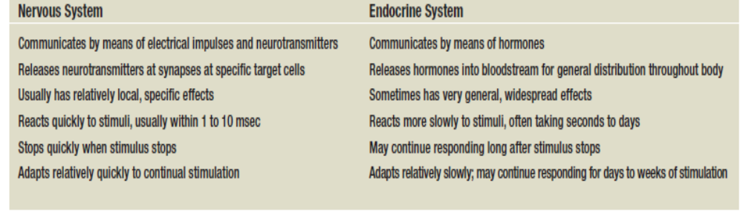
A hormone is a chemical substance secreted in small amounts (10-6 to 10-12M concentration in body fluids) by a cell or a circumscribed group of glandular cells. When secreted, these chemical substances (hormones) sometimes travel from far production points to their target sites where they exert stimulatory or inhibitory effects. Hormones regulate the rates of specific processes without contributing significant amounts of energy or matter to the system.
Generally, hormones are classified based on their
- Site of action and
- Chemical nature
Some endocrine hormones exert their effects within the immediate vicinity of production while others exert their effects in far off zones. The former are known as local hormones because there effect is seen locally, while the later are referred to as general hormones. Based on this, endocrine glands could be grouped into Local hormones and General hormones based on their effects in the body.
Hormones can be classified based on their chemical nature and this gives us essentially two groups:
- Proteins or derivatives of proteins or amino acids and
- Steroidal hormones
NOMENCLATURE
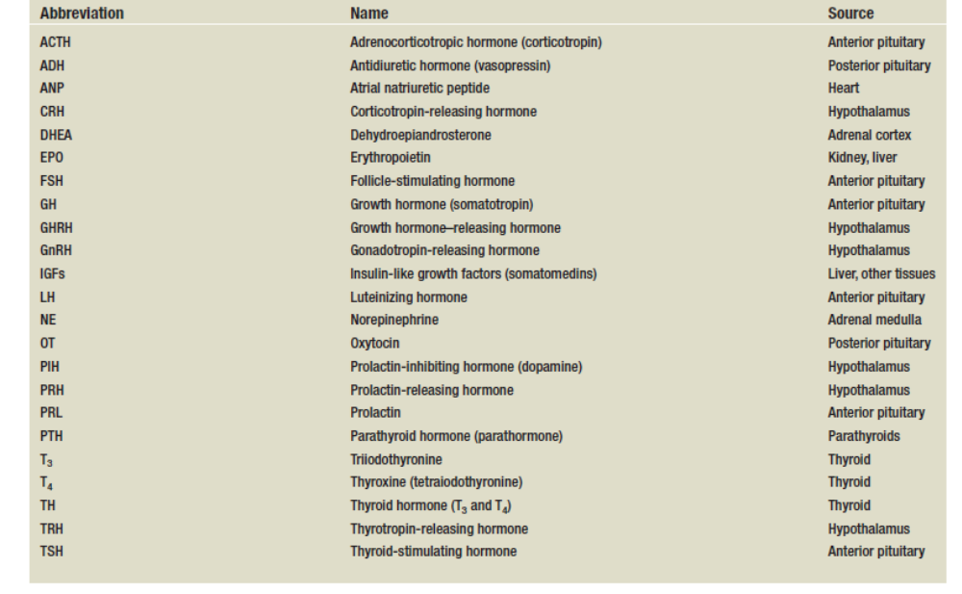HYPOTHALAMIC HORMONES
The hypothalamus seems to be the organ that originates all endocrine functions and also serves as a control center for the body. It releases the following Releasing Hormones that stimulate the release of different hormones from the adenohypophysis:
- Corticotropin Releasing Hormone (C.R.H. causes the release of ACTH)
- Thyrotropin Releasing Hormone (T.R.H. causes the release of Thyroid Stimulating Hormone also called Thyrotropin)
- Gonadotropin Releasing Hormone (GnRH releases LH and FSH.)
- Growth Hormone releasing hormone and Growth Hormone inhibiting hormone
- Prolactin releasing hormone and Prolactin inhibiting hormone

THE PITUITARY HORMONES
This Organ is also known as the hypophysis cerebri. It is seen in all vertebrates known in existence. Its importance in the endocrine system is very unique as the hormones secreted from the anterior pituitary stimulate the functioning of other endocrine glands in the body. Also, the pituitary exerts regulatory roles to the functioning of other organs in the body. Regulatory in the sense that it is able to pick up the presence of hormones which are in excess in the body hence decrease production of its hormones or vice versa. While structural differences occur within animal species, in general, the pituitary is basically composed of two lobes. The anterior hyposis arises from an out pocket of the embryonic pharyngeal invagination called Rathke’s pouch.
- The anterior pituitary or the Adenohypophysis
- The Posterior Pituitary or the Neurohypophysis
The following are the hormones produced by the anterior pituitary
- Thyrotrophic Hormones (This stimulates the thyroid gland for the stimulation of Thyroxin)
- Growth Hormone
- Adrenocorticotrophic Hormone (This stimulates activity at the Adrenal glands)
- Folicular stimulating Hormone (Controls the activity of the gonads)
- Luteinizing Hormone (Also controls activity of d gonads)
- Prolactin
The following hormones are produces by the posterior pituitary
- Antidiuretic Flormone or Vasopressin (This regulates d amount of urine discharged)
- Oxytocin
The Pituitary gland is under the control of the hypothalamus through some hormonal and neural chambers. It is known that the secretary activity of the posterior pituitary arises from the hypothalamus through some neural interconnectivity. The supply of blood and neurons to the pituitary through the hypothalamus is from a capillary system called the hypothalamic-hypophyseal portal system and this has two major functions
- In the supply of blood and nutrients to the pituitary gland
- In the supply of hypothalamic releasing and inhibiting factors that is released into the Pituitary from the median eminence and the tuber cinereum of the hypothalamus
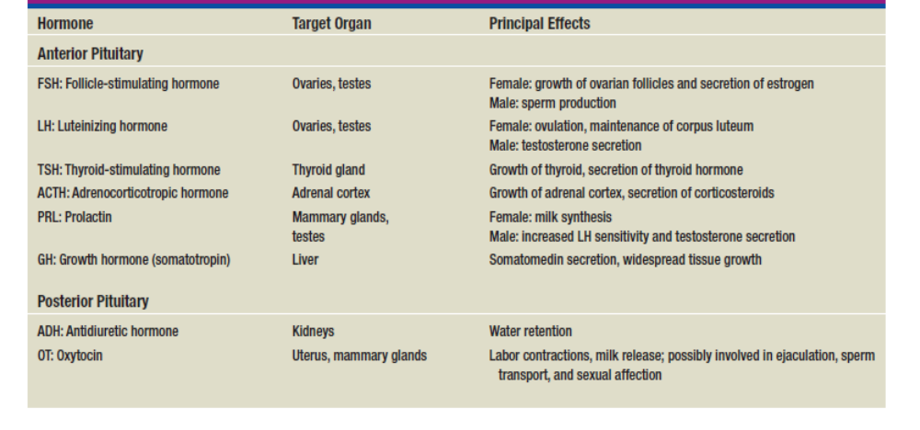
THYROTROPHIC HORMONE
This hormone serves in the stimulation of the effective functioning of the thyroid gland. Thyrotropin literally means to affect the thyroid. Thyro-tropin. Thyro refers to Thyroid. Tropin means it’s something that affects another endocrine gland. So Thyrotropin is a hormone that affects the thyroid.
Thyrotropin stimulates the thyroid gland to secrete tetraiodothyronine (also called Thyroxin, and its tetra— because it has 4 iodine atoms) and a smaller amount of triodothyronine (tri - because it has 3 iodines). These are commonly referred to as T4 and T3. Thyrotropin mostly causes the thyroid gland to secrete T4 and smaller amounts of T3. T3 is more potent but we release less of it.
It is therefore important indirectly in the metabolic regulatory function of the body and thus is involved in the efficient functioning of other hormones in the system
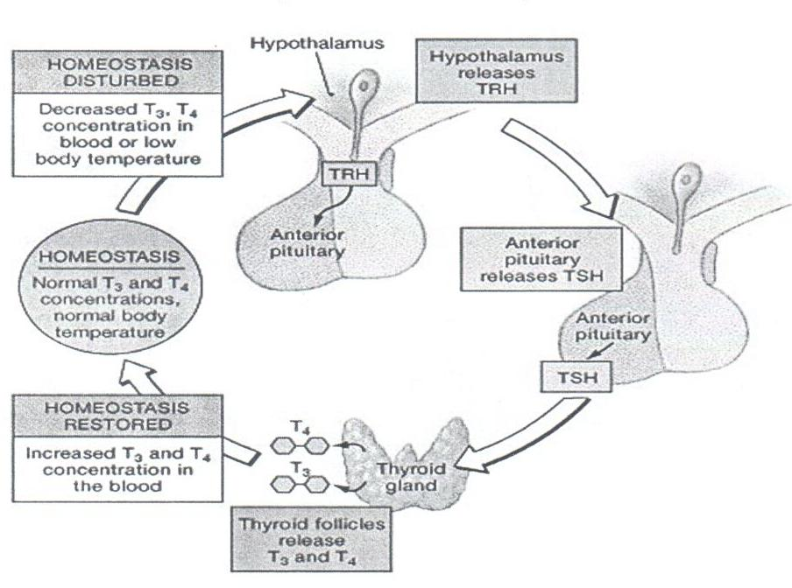

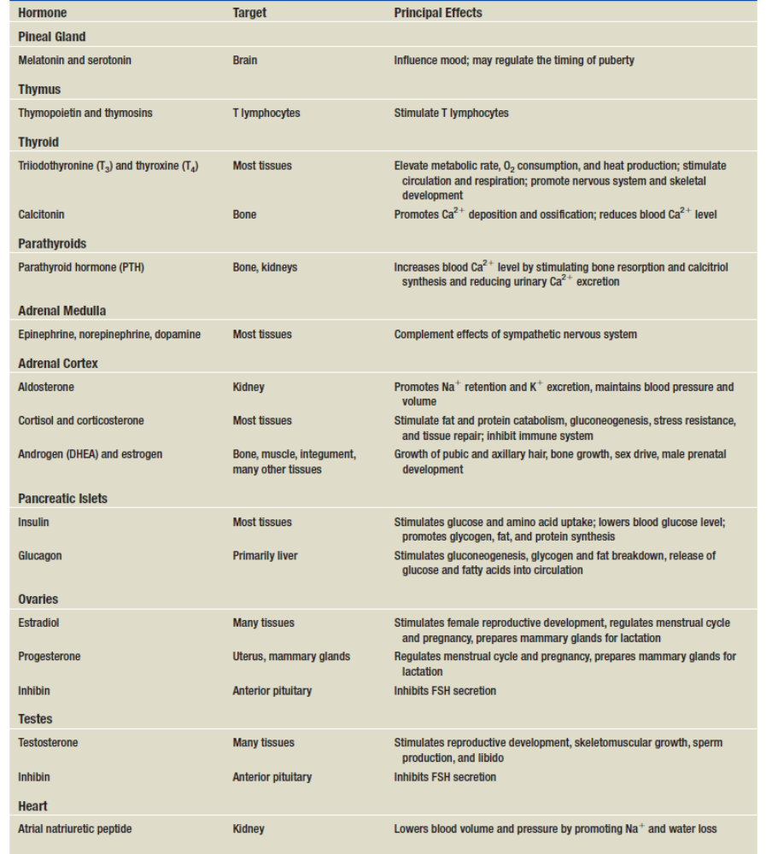
ADENOCORTICOTROPHIC HORMONE
Adrenocorticotropic hormone, also known as corticotropin, is a polypeptide tropic hormone, as its name implies it stimulates the adrenal cortex. More specifically, It is an important component of the hypothalamic-pituitary-adrenal axis and is often produced in response to biological stress. It stimulates secretion of glucocorticoids such as cortisol, and has little control over secretion of aldosterone, the other major steroid hormone from the adrenal cortex. This hormone is essential for the complete functioning of the adrenal cortex. The hormone is a pure protein which has an unusual relative stability towards acids, organic solvents and heat. ACTH is secreted from the anterior pituitary in response to corticotropin-releasing hormone from the hypothalamus.
Corticotropin-releasing hormone is secreted in response to many types of stress, which makes sense in view of the “stress management” functions of glucocorticoids. Corticotropin-releasing hormone itself is inhibited by glucocorticoids, making it part of a classical negative feedback loop. Removal of the pituitary gland causes the adrenal glands to degenerate and become a mare shell. The adrenal cortex may be maintained in the hypophysectomized animal however if only there is a constant injection of adrenocorticotrophic hormone. A deficiency of ACTH is a cause of secondary adrenal insufficiency (primary adrenal insufficiency, also called Addison’s disease, occurs when adrenal gland production of cortisol is chronically deficient, resulting in chronically elevated ACTH levels); when a pituitary tumor is the cause of elevated ACTH (from the anterior pituitary) this is known as Cushing’s Disease and the constellation of signs and symptoms of the excess cortisol (hypercortisolism) is known as Cushing’s syndrome.
GONADOTROPINS
Gonadotropins (or glycoprotein hormones) are protein hormones secreted by gonadotrope cells of the anterior pituitary of vertebrates. This is a family of proteins, which include the mammalian hormones follicle-stimulating hormone (FSH), luteinizing hormone (LH), placental chorionic gonadotropins hCG and eCG and chorionic gonadotropin (CG), as well as at least two forms of fish gonadotropins. These hormones are central to the complex endocrine system that regulates normal growth, Sexual development and reproductive function. The hormones LH and FSH are secreted by the anterior pituitary gland, while hCG and eCG are secreted by the placenta. The two principal gonadotropins in vertebrates are luteinizing hormone (LH) and follicle-stimulating hormone (FSH). although primates produce a third gonadotropin called chorionic gonadotropin (CG). LI-I and FSH are heterodimers consisting of two peptide chains, an alpha chain and a beta chain. LH and FSH share nearly identical alpha chains (about 100 amino acids long), vhereas the beta chain provides specificity for receptor interactions.
FOLLICULAR STIMULATING HORMONE
This is a small glycoprotein with a molecular weight of about 30,000 subunits.
Function
It has its chief function in the females in the development of the ovarian follicles up to the point of ovulation. In the males, FSH is responsible for the development of the seminiferous tubules and in the maintenance of spermatogenesis. FSH stimulates sperm production in testes. In the female, FSH stimulates the growth of the ovarian follicle in the ovaries, and also the follicle cells around it to release estrogen.
Estrogen is a feminizing hormone that affects the woman’s body, skin, breasts, bone and causes a slight thickening of endometrial lining. This first 2 weeks is known as the pre - ovulatory phase (or the follicular phase). Around day 14, after the first 2 weeks, the adenohypophysis starts secreting increasingly-higher amounts of LH and that causes an egg to pop out. Once an egg pops out into the fallopian tube, now a woman could get pregnant and the egg can live only 3—5 days so there’s only a window of 3—5 days where a woman could get pregnant during the cycle. LH is going to be released for 2 weeks, so then we call the ovarian follicle, a corpus luteum. and the ovarian follicles secrete estrogen and progesterone which causes a very strong thickening of the endometrial lining. This is called the luteal (postovulatory phase) because of the release of LH. About day 28, LH is going to stop being released. The drop in the LH level causes the corpus luteum to degenerate and this drop leads to the shedding of the endometrial lining. It was the increase of progesterone that caused the thickening and now the drop in its level causes the shedding out the birth canal. The first day a woman notices this, is considered the first day of menstruation and the cycle starts all over again.
LUTEINIZING HORMONE
This hormone also called the interstitial cell stimulating hormone (ICSH) in the female works in tandem with FSH in the final stage of follicular development and ovulation. LH also stimulates the secretion of estrogen in collaboration with FSH. LH acts on sites of rupture follicles in the ovary to induce luteinization and the secretion of progesterone. These are important factors in the maintenance of pregnancy in animals. In the male, this hormone induces the development of interstitial tissues in the testis (leydig tissue) and in the secretion of androgen.
LH and FSH are referred to as Gonadotriphins and they are responsible for the establishment of secondary sexual characteristics indirectly. They can be detected in the urine and blood of animals that are regnant. They are also seen high in animals that are suffering from genital tumors. Gonadotrophines are also seen to be secreted from the placenta of developing fetuses. Theses however are often called Chorionic Gonadotrophines (CG) or Anterior Pituitary-like hormones (APLH). By age 13, the pituitary gland starts producing FSH and LH in guys, to promote sperm and testusterone and this process continues until the day you die. Sperm levels and testosterone levels go down with time but a 95 year old can still father a child and will try if given the chance. FSH controls the release of estrogen and LH controls the release of progesterone.
PROLACTIN
Prolactin, a non-tropic hormone: The word lacto— means milk. Lactose is the sugar in milk. If a woman is lactating, it means she’s producing milk. Prolactin is the hormone that stimulates the mammary glands to produce milk.
During pregnancy, prolactin stimulates growth of the breast, but high estrogen and progesterone secretion prevent milk production. After delivery, estrogen and progesterone levels drop, and prolactin stimulates the secretion of milk by alveolar cells in the breast. Milk-let down or milk ejection is the name for milk squirting out a nipple.
Suckling by the infant stimulates nipple mechanoreceptors that are connected by neural circuits to neurosecretory cells in the hypothalamus. One type of neurosecretory cell releases the hormone oxytocin from the posterior pituitary. These cells are stimulated by suckling. Oxytocin causes milk ejection, in which smooth muscle-like cells called myoepithclial cells contract and push the milk from the glands into the breast ducts so that the infant can easily suck it out. The other neurosecretory cell that is affected is dopamine. The sucking action of a nursing infant causes a reduction in hypothalamic secretion of dopamine (PIH). In other words, suckling, via neural connections inhibits dopamine secretion, increasing prolactin secretion and stimulating milk production in the breast.
GROWTH HORMONE
Growth Hormone is a non-tropic hormone: also known as somatotropin or somatropin, is a peptide hormone that stimulates growth, cell reproduction and regeneration in humans and other animals. It is a type of mitogen which is specific only to certain kinds of cells. Growth hormone is a 191-amino acid, single-chain polypeptide that is synthesized, stored, and secreted by somatotropic cells within the lateral wings of the anterior pituitary gland. Its function is to stimulate growth in the body, especially the skeletal system and the muscles. G.H. increases protein synthesis and most of the protein in our body is in our muscle cells in the form of actin and myosin. Interestingly, while increased protein synthesis is anabolic, it also promotes the breakdown of glycogen in the liver (glycogenolysis) and lipolysis. It’s kind of like, anti-cortisol because cortisol promotes the breakdown of protein for energy which changes to sugars then fats. G.H. synthesizes protein and breaks down sugars and fats for energy.
Growth Hormone Releasing Hormone (GhRH) released from the hypothalamus causes the release of growth hormone and Growth Hormone Inhibiting Hormone (GHIH also called Somatostatin) inhibits it. Just like prolactin and the mammary gland, there’s no way the GH can go back to the pituitary to create a negative feedback loop. A deficiency of G.H. during childhood means the child’s bones won’t grow normally, which is dwarfism. Don’t confuse this with cretinism, associated with hypothyroidism which affects development of the brain as well. An excess of growth hormone in children results in gigantism where the bones grow too much and they could be 7 to 9 feet tall. Au excess of GH in an adult will cause the bones to grow thicker and that’s called acrormegaly.

Functions of growth hormone;
1. Growth hormone stimulates the growth of bones by stimulating the growth of myelin cartilage (endochondral bone formation). The end of a growing, long-bone is called the epiphysis. The shaft is the diaphysis. The area between the epiphysis and diaphysis is called the epiphyseal plate or bone plate. That’s the last place on the bone that has hyaline cartilage. Growth Hormone stimulates the growth of cartilage at the zone of resting cartilage. When all the hyaline cartilage has turned to bone tissue, your bone can no longer grow longer.
2. Lipid metabolismTo provide energy for growing tissues, GH stimulates adipocytes to catabolize fat and release free fatty acids (FFAs) and glycerol into the blood. GH has a protein-sparing effect—by liberating FFAs and glycerol for energy, it makes it unnecessary for cells to consume their proteins.
3. Carbohydrate metabolism. GH also has a glucosesparing effect. Its role in mobilizing FFAs reduces the body’s dependence on glucose, which is used instead for glycogen synthesis and storage.
4. Electrolyte balance. GH promotes Na_, K_, and Cl_ retention by the kidneys, enhances Ca2_ absorption by the small intestine, and makes these electrolytes available to the growing tissues.

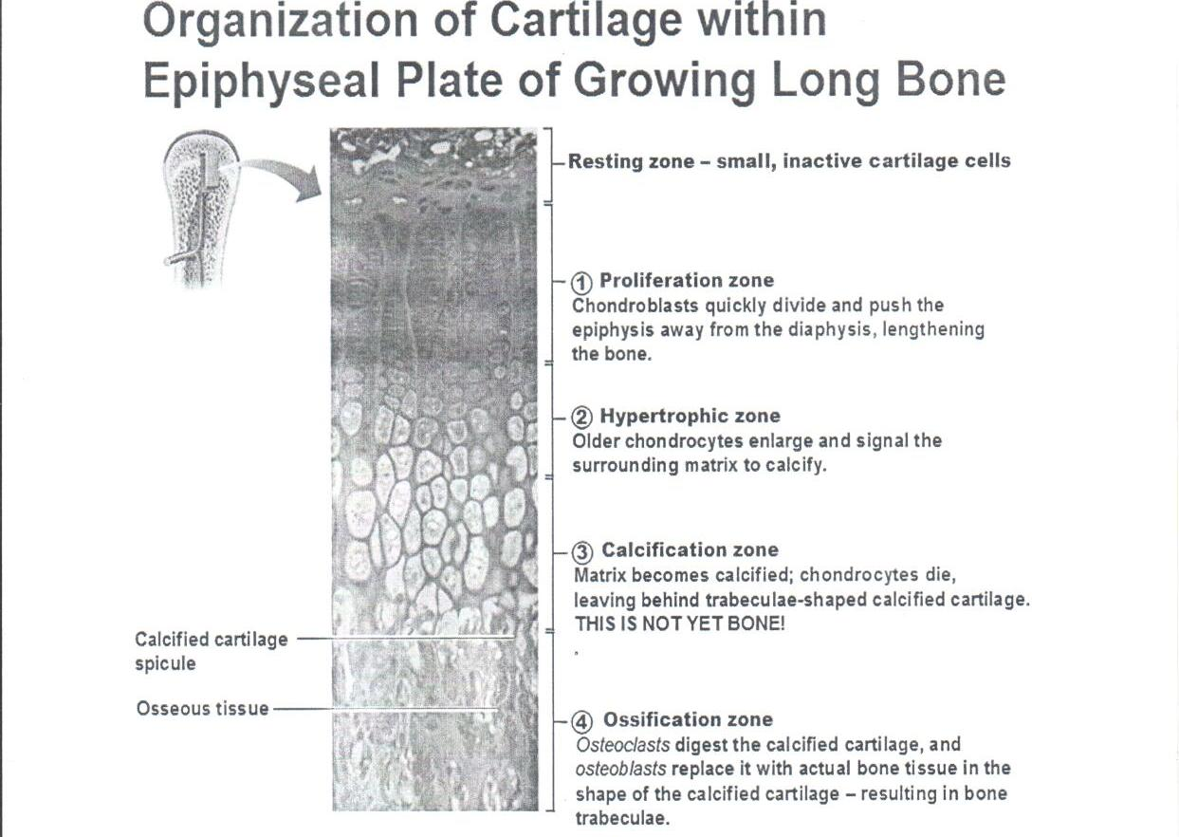
POSTERIOR PITUITARY HORMONES
Antidiuretic Hormone (Vasopressin)
The posterior pituitary produces this hormone and causes the kidneys to reabsorb more water from the excretory fluid (urine). Under a dehydrated state, the posterior pituitary sends ADH to tell the kidneys to retain the water. This is achieved by activating the proximal convoluted tubules to reabsorb more water from the urine as it passes through the kidneys. ADH is also called vasopressin because it causes vasoconstriction at high concentrations. The deficiency of ADH is called diabetes insipidus. Diabetes mellitus is due to an issue with the pancreas not producing enough insulin. The treatment of diabetes insipidus is treated with a replacement of synthetic ADH.
OXYTOCIN
Oxytocin plays roles in sexual reproduction, in particular during and after childbirth. It is released in large amounts after distension of the cervix and uterus during labor, facilitating birth, maternal bonding, and, after stimulation of the nipples, breastfeeding, childbirth and milk ejection. Oxytocin causes contraction of the uterus during labor and at the end of labor, it causes the production of prolactin so that lactation could take place
Function of oxytocin;
- Milk Letdown reflex: In lactating (breastfeeding) mothers, oxytocin acts at the mammary glands, causing milk to he let down’ into subareolar sinuses, from where it can be excreted via the nipple. Suckling by the infant at the nipple is relayed by spinal nerves to the hypothalamus. The stimulation causes neurons that make oxytocin to fire action potentials in intermittent bursts; these bursts result in the secretion of pulses of oxytocin from the neurosecretory nerve terminals of the pituitary gland.
- Uterine Contraction: important for cervical dilation before birth, oxytocin causes contractions during the second and third stages of labor. Oxytocin release during breastfeeding causes mild but often painful contractions during the first few weeks of lactation. This also serves to assist the uterus in clotting the placental attachment point postpartum
- Social behavior and wound healing: Oxytocin is also thought to modulate inflammation by decreasing certain cvtokines. Thus, the increased release in oxytocin following positive social interactions has the potential to improve wound healing.

HORMONES PRODUCED FROM OTHER ENDOCRINE GLANDS IN THE BODY
THYROID GLAND HORMONES
The thyroid hormones, triiodothyronine (T₃) and thyroxine (T₄), are tyrosine-based hormones produced by the thyroid gland that are primarily responsible for regulation of iodine metabolism. Iodine is necessary for the production of T₃ and T₄. A deficiency of iodine leads to decreased production of T₃ and T₄, which further causes the enlargement of the thyroid tissue and will cause the disease known as goitre.
The major form of thyroid hormone in the blood is thyroxine (T₄), which has a longer half-life than T₃. The ratio of T₄ to T₃ released into the blood is roughly 20 to 1. T₄ is converted to the active T₃ (three to four times more potent than T₄) within cells by deiodinases (5’-iodinase). These are further processed by decarboxylation and deiodination to produce iodothyronamine (T_{i}a) and thyronamine (T_{o}a). All three isoforms of the deiodinases are selenium-containing enzymes, thus dietary selenium is essential for T₃ production.
The thyronines act on nearly every cell in the body. They act to increase the basal metabolic rate, affect protein synthesis, help regulate long bone growth (synergy with growth hormone) and neuronal maturation, and increase the body’s sensitivity to catecholamines (such as adrenaline) by permissiveness. The thyroid hormones are essential to proper development and differentiation of all cells of the human body. These hormones also regulate protein, fat, and carbohydrate metabolism, affecting how human cells use energetic compounds. They also stimulate vitamin metabolism. Numerous physiological and pathological stimuli influence thyroid hormone synthesis.
Thyroid hormones (T₄ and T₃) are produced by the follicular cells of the thyroid gland and are regulated by TSH made by the thyrotropes of the anterior pituitary gland. The effects of T₄ in vivo are made via T₃ (T₄ is converted to T₃ in target tissues). T₃ is 3- to 5- fold more active than T₄.
Metabolism: Thyroid hormones stimulate diverse metabolic activities most tissues, leading to an increase in basal metabolic rate. One consequence of this activity is to increase body heat production, which seems to result, at least in part, from increased oxygen consumption and rates of ATP hydrolysis. By way of analogy, the action of thyroid hormones is likened to blowing on a smoldering fire.
Functions of thyroid hormone
- TH is to increase the body’s metabolic rate. As a result, it raises oxygen consumption and has a calorigenic effect—it increases heat production. TH secretion rises in cold weather andthus helps to compensate for increased heat loss. To ensure an adequate blood and oxygen supply to meet this increased metabolic demand, thyroid hormone also raises the heart rate and contraction strength and raises the respiratory rate.
- It accelerates the breakdown of carbohydrates, fats, and protein for fuel and stimulates the appetite. Thyroid hormone promotes alertness, bone growth and remodeling, the development of the skin, hair, nails, and teeth, and fetal nervous system and skeletal development.
- It also stimulates the pituitary gland to secrete growth hormone.
Calcitonin
This is another hormone produced by the thyroid gland. It comes from C (calcitonin) cells, also called parafollicular cells, found in clusters between the thyroid follicles. Calcitonin is secreted when blood calcium level rises. It antagonizes the action of parathyroid hormone (described shortly) and promotes calcium deposition and bone formation by stimulating osteoblast activity. Calcitonin is important mainly to children
Disease conditions associated with thyroid hormone
Hypothyroidism;
- Iodine deficiency: Iodide is absolutely necessary for production of thyroid hormones without adequate iodine intake, thyroid hormones cannot be synthesized.
- Primary thyroid disease: inflammatory disease of the thyroid that destroy part of the gland are clearly and important cause of hypothyroidism.
Common symptoms of hypothyroidism arising after early childhood include lethargy, fatigue, cold-intolerance, weakness, hair loss and reproductive failure. If these signs are severe, the clinical condition is called myxedema. In the case of iodide deficiency, the thyroid becomes inordinately large and is called a Goiter.
The most severe and devastating form of hypothyroidism is seen in young children with congenital thyroid deficiency. If that condition is not corrected by supplemental therapy soon after birth, the child will suffer from Cretinism, a form of irreversible growth and mental retardation.
Hyperthyroidism results from over secretion of thyroid hormones. In most species, this condition is less common than hypothyroidism. In humans the most common form of hyperthyroidism is Graves disease, an immune disease in which autoantibodies bind to and activate the thyroid-stimulating hormone receptor, leading to continual stimulation of thyroid hormone synthesis.
Common signs of hyperthyroidism are basically the opposite of those seen in hypothyroidism, and include nervousness, insomnia, high heart rate, eye disease and anxiety. Graves disease is commonly treated with anti-thyroid drugs (e.g. propyithiourea, methimazole), which suppress synthesis of thyroid hormones primarily by interfering with iodination of thyroglobulin by thyroid peroxidase.
The Parathyroid gland
The parathyroid gland appears as four tiny structures imbedded in the rear surface of the thyroid glands. In about 1960, a chemically pure compound was isolated from the parathyroid glands of cattle. This small protein with a molecular weight of 9500 and containing about 83amino acid units was termed the Parathyroid hormone.

FUNCTIONS ;
They secrete parathyroid hormone (PTH) in response to hypocalcemia. PTH raises blood calcium levels by promoting the synthesis of calcitriol, which in turn promotes intestinal calcium absorption; by inhibiting urinary calcium excretion; by promoting phosphate excretion (so the phosphate does not combine with calcium and deposit into the bones); and by indirectly stimulating osteoclasts to resorb bone.
THE ADRENAL GLAND
The adrenal glands are two small organs located at the top of the kidney. Anatomically and physiologically, there are two major regions; the exterior adrenal cortex and the inner adrenal medulla.
The Adrenal Cortex
The adrenal cortex has three layers of glandular tissue b)—an outer zona glomerulosa composed of globular cell clusters; a thick middle zona fasciculate; composed of cell columns separated by blood sinuses; and an inner zona Reticularis where the cells form a network. The cortex synthesizes more than 25 steroid hormones known collectively as the corticosteroids, or corticoids. The three tissue layers secrete, in the same order, the following corticosteroids:
Glucocortocoids:
Glucocorticoids (mainly zona fasciculata) produce cortisol (hydrocortisone) and corticosterone is a less potent relative. Glucocorticoids stimulate fat and protein catabolism, gluconeogenesis, and the release of fatty acids and glucose into the blood. This helps the body adapt to stress and repair damaged tissues. Glucocorticoids also have an anti-inflammatory effect and are widely used in ointments to relieve swelling and other signs of inflammation. Long-term secretion, however, suppresses the immune system for reasons we will see later in the discussion of stress.

Mineralocorticoids: The chief function of these hormones, of which aldosterone is the most important is to promote the absorption of Na+ and Cl- ions in the tubules of the kidneys. aldosterone, also promotes Na_ retention and K_ excretion by the kidneys. This helps to normalize the blood volume and pressure. The rate of aldosterone secretion is controlled chiefly by the level of Na+ ions in the blood. A decrease in blood sodium stimulates increase in aldosterone secretion and thus an increase in the reabsorbtion of sodium from the kidneys. Also an increase in sodium salt will reverse the secretion. In all animals, mineralocorticoids function in regulating the salt water balance in the animals blood

Sex steroids (mainly zona reticularis), including weak androgens and smaller amounts of estrogens. Androgens control many aspects of male development and reproductive physiology. The principal adrenal androgen is dehydroepiandrosterone (DHEA). DHEA has weak hormonal effects in itself, but more importantly, other tissues convert it to the more potent androgen, testosterone. This source is relatively unimportant in men because the testes produce so much more testosterone than this. In women, however, the adrenal glands meet about 50% of the total androgen requirement. In both sexes, androgens stimulate the development of pubic and axillary hair and apocrine scent glands at puberty, and they sustain the libido (sex drive) throughout adult life. Sometimes, the masculization seen in women (facial hairs, deep voice, angular body contours etc) can be traced to be caused by the adrenal cortex secreting an excess amount of androgen in the female.
Although the sex hormone secreted by the adrenal cortex seems to be of little or no importance, the mineralocorticoids and the glucocorticoids are very essential to life. In some animals, removal of the adrenal cortex may not lead to death if stressful conditions are averted, however in humans, survival is almost impossible. A hypo secretion of these hormones results in Addison’s disease. The symptoms include lower blood pressure, loss of appetite, muscular Weakness and general apathy. Unless corrective measures are taken, death follows after about two years.
The Adrenal Medulla
Although a true endocrine gland, the adrenal medulla is considered to be a part of the nervous system. Its secretary cells seem to be a modified nerve cell. It releases two hormones
- Adrenalin or epinephrine
- Nore adrenalin or norepinepherine
These hormones supplement the effects of the sympathetic nervous system, but their effects last much longer (about 30 min.) because the hormones circulate in the blood. They prepare the body for physical activity in several ways.

Functions;

- They raise the blood pressure and heart rate, increase circulation to the skeletal muscles, increase pulmonary airflow, and inhibit such temporarily inessential functions as digestion and urine formation. . The pupils of the eye dilate and there is a tendency of the hod hair to stand erect. The prepare the animal for fright and flight

- They stimulate glycogenolysis (hydrolysis of glycogen to glucose) and gluconeogenesis (the synthesis of glucose from amino acids and other substrates), thus raising the blood glucose level. In order to further ensure an adequate supply of glucose to the brain, epinephrine inhibits insulin secretion and thus, the uptake and use of glucose by the muscles and other insulin-dependent organs. Thus, epinephrine has a glucose-sparing effect, sparing it from needless consumption by organs that can use alternative fuels to ensure that the nervous system has an adequate supply. The medulla and cortex are not as functionally independent as once thought. The boundary between them is indistinct and some cells of the medulla extend into the cortex. When stress activates the sympathetic nervous system, these medullary cells secrete catecholamines that stimulate the cortex to secrete corticosterone.
The second hormone noradrenaline also causes an increase in blood pressure. It achieves this by stimulating the contraction of the arterioles.

All of its actions lead to an increase of blood calcium level. The hormone also inhibits the reabsorbtion of PO₄³⁻ from the kidney tubules during the formation of urine. This helps to rid the response to an outpouring of ACTH from the pituitary gland. The release of ACTH is in itself triggered by the emotional state of the animal, the lowered level of steroids in the blood and the adrenalin released by the adrenal medulla. During this phase of counter shock, the symptoms of the shock phase are lowered and eventually reversed. The animal then enters into a stage of resistance and becomes adapted to the stress.
Pancreas
It is approximately 15 cm long and 2.5 cm thick. Most of it is an exocrine digestive gland, but scattered through the exocrine tissue are endocrine cell clusters called pancreatic islets (islets of Langerhans20). The islets secrete at least five hormones and paracrine products, the most important of which are insulin, glucagon, and somatostatin.
Insulin
Insulin is a peptide hormone, produced by beta cells of the pancreas, and is central to regulating carbohydrate and fat metabolism in the body. Insulin causes cells in the liver and skeletal muscles, glucose is stored as glycogen, and in fat cells (adipocytes) it is stored as triglycerides.
Insulin stops the use of fat as an energy source by inhibiting the release of glucagon. With the exception of the metabolic diabetes mellitus and metabolic syndrome, insulin is provided within the blood in a constant proportion to remove excess glucose from the blood which otherwise could be toxic when blood glucose levels fall below a certain level, the body begins to use store sugar as an energy source through glycogenolysis, which breaks down the glycogen stored in the liver and muscles into glucose, which can then be utilized as an energy source. As a central metabolic control mechanism, its status is also used as a control signal to other body system (such as amino acid uptake by body cells). In addition, it has several other anabolic effects throughout the body.
Physiologic activity: The actions of insulin (indirect and direct) on cells include:
- Increased glycogen synthesis — insulin forces storage of glucose in liver (and muscle) cells in the form of glycogen; lowered levels of insulin cause liver cells to convert glycogen to glucose and excrete it into the blood. This is the clinical action of insulin, which is directly useful in reducing high blood glucose levels as in diabetes.
- Increased lipid synthesis — insulin forces fat cells to take in blood lipids, which are converted to triglycerides; lack of insulin causes the reverse.
- Increased esterification of fatty acids — forces adipose tissue to make fats (i.e., triglycerides) from fatty acid esters; lack of insulin causes the reverse.
- Decreased proteolysis — decreasing the breakdown of protein
- Decreased lipolysis — forces reduction in conversion of fat cell lipid stores into blood fatty acids; lack of insulin causes the reverse.
- Decreased gluconeogenesis — decreases production of glucose from non-sugar substrates, primarily in the liver (the vast majority of endogenous insulin arriving at the liver never leaves the liver); lack of insulin causes glucose production from assorted substrates in the liver and elsewhere.
- Decreased autophagy - decreased level of degradation of damaged organelles. Postprandial levels inhibit autophagy completely.
- Increased amino acid uptake — forces cells to absorb circulating amino acids; lack of insulin inhibits absorption.
- Increased potassium uptake — forces cells to absorb serum potassium; lack of insulin inhibits absorption. Insulin’s increase in cellular potassium uptake lowers potassium levels in blood. This possibly occurs via insulin-induced translocation of the Na+/K+-ATPase to the surface of skeletal muscle cells
- Arterial muscle tone — forces arterial wall muscle to relax, increasing blood flow, especially in microarteries; lack of insulin reduces flow by allowing these muscles to contract.
- Increase in the secretion of hydrochloric acid by parietal cells in the stomach
- Decreased renal sodium excretion.
Sufficient lack of glucose and scarcity of these sources of glucose can dramatically make itself manifest in the impaired functioning of the central nervous system: dizziness, speech problems, and even loss of consciousness. Low blood glucose level is known as hypoglycemia or, in cases producing unconsciousness, “hypoglycemic coma” (sometimes termed “insulin shock” from the most common causative agent). Endogenous causes of insulin excess (such as an insulinoma) are rare, and the overwhelming majority of insulin excess-induced hypoglycemia cases are iatrogenic and usually accidental. A few cases of murder, attempted murder, or suicide using insulin overdoses have been reported, but most insulin shocks appear to be due to errors in dosage of insulin (e.g.. 20 units instead of 2) or other unanticipated factors (did not eat as much as anticipated, or exercised more than expected, or unpredicted kinetics of the subcutaneously injected insulin itself).
Possible causes of hypoglycemia include:
- External insulin (usually injected subcutaneously)
- Oral hypoglycemic agents (e.g., any of the sulfonylureas, or similar drugs, which increase
insulin release from 13-cells in response to a particular blood glucose level)
- Ingestion of low-carbohydrate sugar substitutes in people without diabetes or with type 2 diabetes. (This can never be a cause of hypoglycemia in patients with type I diabetes, since there is no endogenous insulin production to stimulate.)
Disease conditions associated with insulin
- Diabetes mellitus — general term referring to all states characterized by hyperglycemia
- Type I — autoimmune-mediated destruction of insulin-producing 13-cells in the pancreas, resulting in absolute insulin deficiency
- Type 2 — multifactoral syndrome with combined influence of genetic susceptibility and influence of environmental factors, the best known being obesity, age. and physical inactivity, resulting in insulin resistance in cells requiring insulin for glucose absorption. This form of diabetes is strongly inherited.
- Other types of impaired glucose tolerance (see the Diabetes)
- Insulinoma - a tumor of pancreatic 13-cells producing excess insulin or reactive hypoglycemia.
GLUCAGON
Glucagon, a peptide hormone secreted by the pancreas, raises blood glucose levels. Its effect is opposite that of insulin, which lowers blood glucose levels, The pancreas releases glucagon when blood sugar (glucose) levels fall too low. Glucagon causes the liver to convert stored glycogen into glucose, which is released into the bloodstream. High blood glucose levels stimulate the release of insulin. Insulin allows glucose to be taken up and used by insulin- dependent tissues. Thus, glucagon and insulin are part of a feedback system that keeps blood glucose levels at a stable level.
Production: The hormone is synthesized and secreted from alpha cells (a-cells) of the islets of Langerhans, which are located in the endocrine portion of the pancreas. In rodents, the alpha cells are located in the outer rim of the islet. Human islet structure is much less segregated, and alpha cells are distributed throughout the islet.
Regulation: Secretion of glucagon is stimulated by: Hypoglycemia, Epinephrine, Arginine, Al an i ne (often from muscle-derived pyruvate/glutamate transamination, Acetylcholine, and ChoIecystokinin.
Secretion of glucagon is inhibited by: somatostatin, insulin, increased urea production, increased free fatty acids and keto acids into the blood.
Glucagon generally elevates the amount of glucose in the blood by promoting gluconeogenesis and glycogenolysis. Glucose is stored in the liver in the form of glycogen, which is a starch-like polymer chain made up of glucose molecules. Liver cells (hepatocytes) have glucagon receptors. When glucagon binds to the glucagon receptors, the liver cells convert the glycogen polymer into individual glucose molecules, and release them into the bloodstream, in a process known as glvcogenolysis. As these stores become depleted, glucagon then encourages the liver and kidney to synthesize additional glucose by gluconeogenesis. Glucagon turns off glycolysis in the liver, causing glycolytic intermediates to be shuttled to gluconeogenesis.
Glucagon also regulates the rate of glucose production through lipolysis. Glucagon has a minimal effect on lipolysis in humans. Glucagon production appears to be dependent on the central nervous system through pathways yet to be defined.
Somatostatin is secreted by the delta cells when blood glucose and amino acids rise after a meal. Somatostatin travels briefly in the blood and inhibits various digestive functions, but also acts locally in the pancreas as a paracrine secretion—a chemical messenger that diffuses through the tissue fluid to target cells a short distance away. Somatostatin inhibits the secretion of glucagon and insulin by the neighboring _ and _ cells.

Any hormone that raises blood glucose concentration is called a hyperglycemic hormone. You may have noticed that glucagon is not the only hormone that does so; so do growth hormone, epinephrine, norepinephrine, cortisol, and corticosterone. Insulin is called a hypoglycemic hormone because it lowers blood glucose levels.
THE GONADS
The gonads are both endocrine and exocrine. Their exocrine products are eggs and sperm, and their endocrine products are the gonadal hormones, most of which are steroids. Each follicle of the ovary contains an egg cell surrounded by a wall of granulosa cells. The granulose cells produce an estrogen called estradiol in the first half of the menstrual cycle. After ovulation, the corpus luteum secretes estradiol and progesterone for 12 days or so, or for 8 to 12 weeks in the event of pregnancy. Estrogens and progestins are steroid hormones with numerous physiological actions. In women, these include developmental effects, control of ovulation, cyclical preparation of the reproductive tract for fertilization and implantation, and metabolic actions. Estrogens also have important actions in males, including effects on bone, spermatogenesis, and behavior. Estrogens and progestins are used in menopausal hormone therapy (MHT) and contraception in women.
The gonadal hormones are produced in the ovaries of the female and the testes of the male species. They are the androgens, estrogens and the progesterone. These hormones are steroids and are related to a group of organic alcohols known as sterols. Cholesterol is the basic substance for synthesis of all steroidal hormones. The ovary is the major site of estrogen and progestin biosynthesis in non-pregnant premenopausal women. In pregnant women, the feto-placental unit is the major source of estrogens and progestins. Peripheral sites of estrogen synthesis include the liver, kidney, brain, adipose tissue, skeletal muscle, and testes. Progesterone is secreted in small amounts by the testes and adrenal gland. Progesterone is secreted in small amounts by the testes and adrenal gland.
Testosterone is secreted primarily by the testicles of males and the ovaries of females, although small amounts are also secreted by the adrenal glands. It is the principal male sex hormone and an anabolic steroid. testosterone plays a key role in the development of male reproductive tissues such as the testis and prostate as well as promoting secondary sexual characteristics such as increased muscle, bone mass, and the growth of body hair.
ESTROGEN
Estrogens are synthesized in all vertebrates as well as some insects. Estrogens, in females, are produced primarily by the ovaries, and during pregnancy, the placenta. Follicle-stimulating hormone (FSH) stimulates the ovarian production of estrogens by the granulosa cells of the ovarian follicles and corpora lutea. Some estrogens are also produced in smaller amounts by other tissues such as the liver, adrenal glands, and the breasts. Fat cells produce estrogen as well. [Nelson, 2001] In females, synthesis of estrogens starts in theca interna cells in the ovary, by the synthesis of androstenedione from cholesterol. Androstenedione is a substance of weak androgenic activity which serves predominantly as a precursor for more potent androgens such as testosterone as well as estrogen. This compound crosses the basal membraneinto the surrounding granulosa cells, where it is converted either immediately into estrone, or into testosterone and then estradiol in an additional step. The conversion of androstenedione to testosterone is catalyzed by 17β-hydroxysteroid dehydrogenase(17β-HSD), whereas the conversion of androstenedione and testosterone into estrone and estradiol, respectively is catalyzed by aromatase, enzymes which are both expressed in granulosa cells. Estrogen levels vary through the menstrual cycle, with levels highest near the end of the follicular phase just before ovulation.
The female naturally produce 3 forms of estrogen. They are the estrone, estradiol and estriol. The estradiol is the major secretory product of the ovary and most active of the 3 in vet practices; stilbesterol, stilbesterol diproprionate and the estradiol monobenzoate are the most commonly used.
Estradiol, or more precisely, 17β-estradiol, is a human sex hormone and steroid, and the primary female sex hormone. It is named for and is important in the regulation of the estrous and menstrual female reproductive cycles. Estradiol is essential for the development and maintenance of female reproductive tissues [Ryan, 1982] Estradiol should be avoided when there is undiagnosed abnormal genital bleeding, known, suspected or a history of breast cancer, current treatment for metastatic disease, known or suspected estrogen-dependent neoplasia, deep vein thrombosis, pulmonary embolism or history of these conditions, active or recent arterial thromboembolic disease such as stroke, myocardial infarction, liver dysfunction or disease. Estradiol should not be taken by people with a hypersensitivity/allergy or those who are pregnant or are suspected pregnant. Estradiol, like other steroids, is derived from cholesterol. After side chain cleavage and using the delta-5 or the delta-4 pathway, androstenedione is the key intermediary. A fraction of the androstenedione is converted to testosterone, which in turn undergoes conversion to estradiol by an enzyme called aromatase( process of aromatization)
Estrogen is obtained from the urine of the stallion (equilenin and equilin) in large quantities where they are recovered for medicinal purposes. Estrogen sensitivity is higher in cow followed by the sheep, pig and horse being the least sensitive. Estrogen therapy is recognized in the cattle industry. [Asuzu et al., 2012]
Equilin
Equilin is an estrogen from horses with the chemical name 3-hydroxyestra-1,3,5,7-tetraen-17-one. Equilin is one of the estrogens present in the mixture of estrogens isolated from horse urine and marketed as Premarin. Estrone is a major estrogen that is normally found in women. Equilin is not normally present in women, so there has been interest in the effects of equilin on the human body. [Sawicki, 1999] Estrone sulfate is usually the major form of estrogen in women. Estrone can be converted to estradiol, which is thought to be the major active estrogen in women. [Sawicki, 1999]
Diethylstilbesterol is a synthetic hormone with a similar function to estrogen. It acts for a longer period of time. A preparation of stilbesterol known as repositol suspended in water as droplets is available. It could last for 4 weeks when administered subcutaneously in both humans and animals. [Asuzu et al., 2012]
Pharmacological actions of estrogen
Effect on growth and development
Estrogen is known to stimulate development of secondary sex characteristics in female. Estrogens cause the growth of the uterus, fallopian tubes, and vagina. breast enlargement, the distribution of body hair, body contours as determined by subcutaneous fat deposition, and skin texture. During development, estrogens stimulate proliferation of the ductal epithelial cells in breast tissue. [Hill et al., 2004]
Estrogen stimulates stromal development and growth of mammary duct as well as growth of nipples. In large doses, it can cause inhibition of pituitary activity. This mechanism suppresses lactation. [Hill et al., 2004]
Effect on bones
Estrogen accelerate growth phase and closure of the epiphyses of long bones at puberty. [Asuzu et al., 2012] Estrogens can stimulate the release of growth hormone and exert a positive effect on nitrogen balance. These effects contribute to the growth spurt during puberty. Closure of the bone epiphyses signaling the end of long bone growth is also estrogen mediated. [Ritter et al., 2008] Estrogens maintain bone mass by inhibiting bone resorption by the osteoclasts. Estrogens inhibit the production of cytokines by peripheral blood cells and the osteoblasts that stimulate osteoclast activity. [Ritter et al., 2008]
Effect on the uterus; Estrogen enhances the sensitivity of uterus to oxytocin [Asuzu et al., 2012]. It increases the ecbolic effect of oxytoxin in the uterus.
Other identifiable effects;
Estrogen is responsible for estrus behavior in animals and also influence libido in humans.
Estrogens increase the synthesis of many liver proteins, including transferrin, corticosteroid-binding globulin, thyroid-binding globulin, and proteins involved in blood clotting. [Warnock et al., 2005]
In males, estrogens stimulate the growth of the stromal cells in the accessory sex organs.
Uses
(a) It is used to induce estrus
(b) It is used for the removal of retained placenta and expulsion of mummified fetus.
(c) It is used to promote growth in fattening steers. This treatment is not given to heifers and cows because of the side effect which are nymphomania, vaginal prolapse, and faulty calcium metabolism which can result to pelvic or vertebral fracture.
(d) It is used in treatment of mesalliance. [Asuzu et al., 2012]
(e) It is used for caponization in poultry.
(f) It is used for the treatment of pseudopregnancy and preventing vaginitis of non specific origin.
(g) It is used to induce fake lactation. Serous secretion is produced not milk
(h) it is used to induce abortion in cows especially in feed lot.
Progesterone
Progesterone is an endogenous steroid hormone involved in the menstrual cycle, pregnancy, and embryogenesis of humans and other species. [King and Brucker, 2010] It belongs to a group of steroid hormones called the progestogens, [King and Brucker, 2010] and is the major progestogen in the body. Progesterone is also a crucial metabolic intermediate in the production other endogenous steroids, including the sex hormones and the corticosteroids, and plays an important role in brain function as a neurosteroid. [Baulieu and Schumacher, 2000]
The use of progesterone is not yet extensive in vet practices. It is synthesized from acetate, cholesterol and pregnanolone in the ovary, testes and adrenal gland. Progesterone is produced at the corpus luteum in the ovary and secreted in substantial quantity during the luteal phase. [Asuzu et al., 2012] Man and horse depend on the progesterone produced by the corpus luteum during the whole of pregnancy while cow and sheep depend on it for the 1st one third of pregnancy after which they depend solely on the placenta for supply.
Acetate > cholesterol > pregnanolone > progesterone > pregnanediol > sodium p regnanediol-20-glucuronide
Pharmacological actions
(a) It decreases the thickness of vaginal epithelium with loss of the cornified layer.
(b) It softens the cervix and makes it thin walled.
(c) It competes with aldosterone at the renal tubules to decrease sodium reabsorption.
(d) It maintains pregnancy by reducing contractility and excitability of the endometrium
(e) It reduces the plasma level of many aminoacid and increase urinary nitrogen excretion (f)it increases the glandular structure of the endometrium
Uses
(a) Progesterone is used for estrus synchronization in cow and sow by deferring estrus.
(b) It is used to suppress estrus (c) it is used in case of threatened abortion.
In humans, its main use is for oral contraception.
Testosterone
This is produced by the leydig cells found in the spaces between the seminiferous tubules. The production is controlled by the lutenizing hormone which is also controlled by the lutenizing hormone releasing factor in the hypothalamus. It is primarily a male hormone. [Asuzu et al., 2012]
Testosterone is metabolized in the liver to androsterone and etiocholanolone which are biologically inactive. Dihydrotestosterone is metabolized to androsterone, androstanedione, and androstanediol. [Laurence et al., 2008] Testosterone can be administered orally as well as intramuscularly and it is well absorbed. It is excreted as 17 keto steroid. (A low level indicates hypoactivity while higher level indicates hyperactivity)
Function
- Testosterone is responsible for development of secondary sex characteristics in male at puberty.
- Testosterone plays a role in spermatogenesis from level of primary spermatocyte to mature spermatozoa.
- It increases libido in male. Testosterone stimulates production of RNA and protein.
- Testosterone is known to decreases urine nitrogen excretion which indicates increased protein synthesis or decreased protein breakdown [Bassil et al., 2009.
Uses
(a) It is used in conditions as cryptochidism.
(b) It is used to increase weight gain.
(c) It is used to treat hypogonadal infertility and overcome wasting in wasting diseases.

Several other organs have hormone-secreting cells:

• The heart. High blood pressure stretches the heart wall and stimulates muscle cells in the atria to secrete atrial natriuretic22 peptide (ANP). ANP increases sodium excretion and urine output and opposes the action of angiotensin II, described shortly. Together, these effects lower the blood pressure.

• The skin. Keratinocytes of the epidermis produce vitamin D3, the first step in the synthesis of calcitriol. Its synthesis is completed by the liver and kidneys.

• The liver. The liver converts vitamin D3 to calcidiol, the second step in calcitriol synthesis. It is one of the sources of IGF-I, which mediates the action of growth hormone. It secretes about 15% of the body’s erythropoietin (EPO, a hormone that stimulates the bone marrow to produce red blood cells. The liver also secretes a hormone precursor called angiotensinogen. In the blood, angiotensinogen is converted to angiotensin I by a kidney enzyme (renin) and then to angiotensin II by a lung enzyme (angiotensin-converting enzyme, ACE). Angiotensin II is a hormone that stimulates vasoconstriction and aldosterone secretion. Together, these effects raise blood pressure.

• The kidneys. The kidneys convert calcidiol to calcitriol, the active form of vitamin D. Calcitriol promotes calcium absorption by the small intestine, somewhat inhibits calcium loss in the urine, and thus makes more calcium available for bone deposition and other metabolic needs. The kidneys also produce about 85% of our EPO, and convert angiotensinogen to angiotensin I. erythopoeitin is secreted majorly by the kidney.

• The stomach and small intestine. These have various enteroendocrine cells which secrete at least 10 enteric hormones. In general, they coordinate the different regions and glands of the digestive system with each other

• The placenta. This organ performs many functions in pregnancy, including fetal nutrition and waste removal. But it also secretes estrogen (estriol and estradiol), progesterone, and other hormones that regulate pregnancy and stimulate development of the fetus and the mother’s mammary glands.

Prostaglandins
They are local hormones consisting of lipids and play a role in physiology of conception and parturition. They are found in many tissues and secretions including ovaries, intestine, fat lungs, kidneys, adrenals, liver, pancreas, heart, prostate gland, seminal plasma, menstrual fluid, amniotic fluid. Prostaglandins are the class of physiologically active substances present in many tissues, with effects such as vasodilation, vasoconstriction, stimulation of intestinal or bronchial smooth muscle, uterine stimulation, and antagonism to hormones influencing lipid metabolism.
Mechanism of action
The effect of prostaglandins varies with species. They provide chelating sites and carry Ca⁺⁺ through cell membranes. This does not really explain all the observations concerning PGs.
Pharmacological /physiological effect of prostaglandins
Uterus; It induces parturition or abortion in pregnant patients with or without a progesterone antagonist. When they are used for systemic effect, they cause diarrhea, nausea, vomiting and pain at site of infusion
Vasodilation; PGE₂ and PGI₂ produce vasodilatation locally. Their actions augment the effect of histamine and kinin. They mediate vasodilation of inflammation as well as maintaining homeostasis by providing blood flow to ischaemic tissues. PGE increase sodium excretion produces diuresis and increase stroke volume and lower arterial pressure in humans. [Nelson et al., 2005]
Vasoconstriction; PGF₂ and TXA₂ (thromboxane) are generally vasoconstrictors. They constrict arterioles and vein but don’t affect blood pressure in man. They also constrict umbilical and placenta vessels. [Nelson et al., 2005]
Effect on smooth muscle
PGD₂ and PGF₂ are generally thought to contract smooth muscle. PGE and PGF may augment the contraction of non pregnant uterus and of the uterus throughout pregnancy. It also increase intestinal motility and dilates bronchioles. PGD₂ may be involved during anaphylactic shock.
Inflammation;PGE and PGI are involved in acute inflammatory response alongside histamine and kinins.
Fever; This is mediated byPGE1. Endogenous pyrogens activate the anterior hypothalamus which releases PGE. PGE stimulates posterior hypothalamus to conserve heat.
Pain; PGI and PGE work in synergy with bradykinins to participate inpain process by evoking pain and analgesic response
Other effects; PGE inhibits gastric secretion stimulated by food or histamine.

RESPIRATORY SYSTEM
The respiratory system (or ventilatory system) is the biological system that introduces respiratory gases to the interior and performs gas exchange. Also various structures associated with this passage way modify or regulate flow of air, bringing it into closer relationship with the circulating blood, transport the oxygen to tissue and consequently carry carbon dioxide back to the lungs and serve as olfactory receptor, facilitates water and heat exchange and also for phonation.
External respiration; this is the gaseous exchange between the environment and the blood in the capillaries.

Internal respiration; this is the complicated physiological process of oxidation in the cell. . Glucose is often the energy source but it may also come from other carbohydrates, as well as fats and protein. The energy is made by the biochemical process known as cellular respiration that takes place in the mitochondria inside every living cell.
The overall reaction can be summarised by the word equation given below.
Carbohydrate Food (glucose) + Oxygen = Carbon Dioxide + Water + energy
The two forms of respiration, the result is the absorption of oxygen, discharge of carbon dioxide by the tissues and generation of energy within the cell.
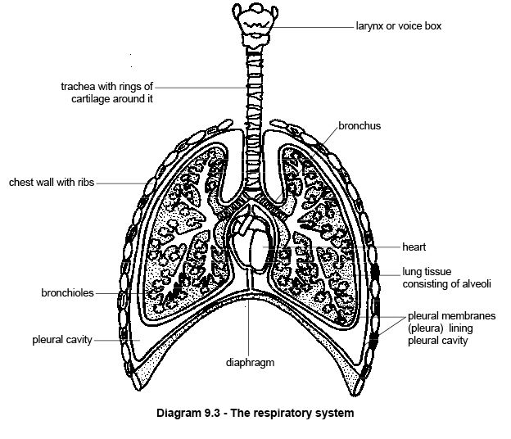
Some terminologies used in respiration
Inspiration; this is the inflow of air from the environment into the lungs through the air passageway. It is characterized by an enlargement of the thorax and lungs. This is usually accomplished by the by the contraction of the diaphragm from its dome shape to flattening and by the forward and outward movement of the ribs as facilitated by the contraction of the chest muscles (intercoastal muscle) .
The diaphragm is a thin sheet of muscle that completely separates the abdominal and thoracic cavities. When at rest it domes up into the thoracic cavity but during breathing in or inspiration it flattens. At the same time special muscles in the chest wall move the ribs forwards and outwards. These movements of both the diaphragm and the ribs cause the volume of the thorax to increase. Because the pleural cavities are airtight, the lungs expand to fill this increased space and air is drawn down the trachea into the lungs.
Expiration; this is an outflow of air from the lungs to the environment through the air passageway. It consists of the opposite movements. The ribs move down and the diaphragm resumes its domed shape so the air is expelled. Expiration is usually passive and no energy is required (unless in cases as coughing, talking, laughing, barking, croaking, blowing of balloon).
Eupnea; this is the state of normal quiet breathing. The animal is unconscious of the effort required to produce the thoracic movements.
Dyspnea; this is the condition of labored or difficulty in breathing.
Hypernea; this is the condition of increased breathing rate or depth or both
Apnea; this is cessation of breathing
Tidal volume; this is the volume of air inspired or expired in one respiration. This varies with body weight in an animal at rest
TV= 0.0074 x body weight.
TV is expressed in mililitre(ml).
Polypnea; this is rapid, shallow, panting type of respiration.
Inspiratory reserve volume; volume of air that can be inspired by the deepest possible inspiration after an ordinary inspiration
Expiratory reserve volume; volume of air that can be expired by the deepest possible expiration after an ordinary expiration
Residual volume; this is the amount of air that the lungs contain after the expiratory reserve volume.
Normal volume; this is the amount of air left in the lungs following a quiet expiration. It is also called the functional residual capacity.
Dead space; this is the respiratory passage extending from the external nares to the alveoli. This passage consists of the nasal passage, pharynx, the trachea, bronchi, and non functional alveoli.
Compliance; this is the term used to describe the expansibility of the lungs and thorax during respiration, the thorax and the lung characteristically expand following inspiration and passively relax during expiration. The arrangement of the ribs and the intercoastal muscles make for the volume changes of the thorax while the elastic nature of the lungs enhances its expansion during these phases of respiration.
This ventilatory system comprises the lungs and other organs involved in the air passage. They include;
Nose and Nasal cavity; this is the facial part of the respiratory system. It extends from the nostril which is divided into left and right halves by the nasal septum called the nasal vestibule. Each half is known as nasal fossa. During development lateral and dorsal walls of the nasal fossa results in the formation of turbinate folds which fills the nasal cavity .this turbinate bones are called conchas. Superior and lateral walls of the nasal cavity are formed of nasal, maxillary, ethmoid, frontal and sphenoid bones. The floor of nasal cavity is formed of hard and soft palates.
The external nose consists of a fixed bony case and a movable cartilaginous framework. The apical portion of the nose is flattened and devoid of hair. The form and size of nostril, their orientation, and nature of their intergument show considerable species differences.
The function of the nose is to filter, warm and moisten the air before it moves on to other parts of the respiratory tract. The tiny hairs trap the dust particles, bacteria and other foreign bodies that enter the nose. These hairs also induce sneezing to remove foreign bodies lodged in the nose. The wall of the nasal cavity contains many blood vessels; heat from them warms the air as we the animal breaths in
Pharynx
Pharynx is a tubular part of the respiratory system which allows the passage of air into lungs. It is located behind the nasal and oral cavities. The different parts of pharynx are as follows:
Nasopharynx:It connects the upper portion of the throat with the nasal cavity.
Oropharynx:It is located between the soft palate and upper part of epiglottis.
Laryngopharynx:This part of the pharynx is located below the epiglottis. It opens into the esophagus and larynx.
Pharynx is connected to the skull cavity by means of muscles and connective tissues. The pharynx acts like a station where the food tube and the air tube meet. Food swallowed is prevented from entering the air tube by a thin structure, called epiglottis. Epiglottis is composed of cartilaginous tissue. It is located at the opening of larynx (back of the tongue); the epiglottis is covered with mucous. Since the epiglottis gets abraded easily (it lies in the digestive tract), its surface is covered with a layer of non-keratinized and stratified squamous epithelial cells.
Larynx
This is a muscular cartilaginous organ which connects the trachea with laryngopharynx. The larynx controls the flow of air at the time of breathing. It serves for vocalization and prevents inspiration of foreign materials. The larynx, also known as sound box, is formed of cartilages. Epiglottis, thyroid and cricoid are the three important cartilages of larynx; other cartilages present inside the larynx are corniculate, arytenoid and cuneiform.
Trachea
This organ is also known as windpipe, the trachea forms a continuous system of tube conducting air between the larynx and smaller passages (bronchioles) in the lungs.they have similar construction and sometimes referred to as trachoebronchial tree. Trachea lies to the anterior side of the esophagus; it is tubular in shape with a diameter of 1 inch and length of 4.25 inch. Length of the trachea spans between the 6th cervical and 5th thoracic vertebrae. The trachea is composed of 15-20 C-shaped pieces of hyaline cartilage. These pieces are held together by tracheal muscles. The trachea, or windpipe, begins just below the larynx and ends behind the upper part of the breastbone where it divides to form two tubes. The trachea is made of elastic tissue and smooth muscle. It also has rings of elastic cartilage that keep the trachea open when the neck moves. It is lined with a mucous membrane and hair like projections called cilia. Mucus helps trap dust and bacteria in the incoming air. The cilia move the mucus upward to clear the respiratory tract.
The trachea bifurcates/divides into left and right bronchi to enter the corresponding lungs at the root.
Note; The trachea branches into two tubes-the bronchi. Each bronchus (singular of bronchi) enters the lung and branches into narrower tubes called bronchioles . The walls of the bronchi and larger bronchioles are supported by cartilage. Their walls produce mucus which is moved upward by the cilia to clear the air passage. Each bronchiole ends in balloon like air sacs called alveoli. The alveoli have thin walls which are surrounded by blood vessels. The bronchi and bronchioles form the air passage into the lungs. The exchange of oxygen and carbon dioxide takes place in the alveoli. There are about 300 million alveoli in the lungs. These alveoli increase the surface area of the lungs and allow many blood vessels to collect oxygen.
Bronchial tree
This is the route air takes from the trachea to various parts of the lungs. This organ begins at the bifurcation of the trachea by formation of the right and left principal bronchi. Each bronchus divides into a lobar (secondary bronchi).this supply various lobes of the lungs and is numbered according to the lobe they supply. Within each lobe, the lobar bronchi divide into segmental bronchi (tertiary bronchi). The segmental bronchi usually branch into sub-segmental bronchi. This process of branching continues into the bronchioles. The bronchioles (respiratory bronchioles) give rise to the alveolar duct into the alveolar sac into the pulmonary alveoli where gaseous exchange takes place. The alveoli function like an interface for the exchange of oxygen and carbon dioxide between lungs and capillaries. Capillaries connect the alveoli with the rest of the body. Alveoli are found in the lungs of mammals only.

Lungs
Two lungs are present. They lie in the chest cavity and are surrounded by the rib cage. Each lung is enclosed in the double membrane called the pleura . The pleurae are coated by fluid. This allows the lungs to slide freely as they expand and contract during breathing. The right lung has three lobes while the left lung has two. Each lobe has its own bronchi, bronchioles and blood vessels. The lungs are the main organs of the respiratory system. Their function is to supply the body with oxygen and remove carbon dioxide from the blood.
Diaphragm
The diaphragm is formed of skeletal muscles. It creates a partition between the thoracic and abdominal cavity. Contraction of muscles of the diaphragm leads to expansion of the thoracic cavity; contraction of diaphragm is important from the point of expansion of lungs at the time of inhalation.

Gas Exchange Process
The process of gas exchange in alveoli is characterized by inhalation of oxygen and exhalation of carbon dioxide. Oxygen enters the blood cells by means of alveoli and a network of capillaries. Oxygen is carried to the tissues of different parts of the body by means of blood. Carbon dioxide is collected by the blood and carried to lungs. Carbon dioxide diffuses from capillaries that surround the alveoli and is finally exhaled by lungs.
The process of respiration takes place in four stages: ventilation, pulmonary gas exchange, gas transport and peripheral gas exchange. In the ventilation stage, air moves in and out of the alveoli of lungs. The gas exchange which takes place between pulmonary capillaries and alveoli is termed as pulmonary gas exchange. Movement of gas within pulmonary capillaries, towards peripheral capillaries and back to lungs is referred to as gas transport. The exchange of gases between tissues and tissue capillaries is referred to as peripheral gas exchange.
Upon inhalation, gas exchange occurs at the alveoli, the tiny sacs which are the basic functional component of the lungs. The alveolar walls are extremely thin (approx. 0.2 micrometres). These walls are composed of a single layer of epithelial cells close to the pulmonary capillaries which are composed of a single layer of endothelial cells. The close proximity of these two cell types allows permeability to gases and, hence, gas exchange. This whole mechanism of gas exchange is carried by the simple phenomenon of pressure difference. When the air pressure is high inside the lungs, the air from lungs flow out. When the air pressure is low inside, then air flows into the lungs.
Avian respiratory system
The avian respiratory system is involved in the following functions: absorption of oxygen (O2), release of carbon dioxide (CO2), release of heat (temperature regulation), detoxification of certain chemicals, rapid adjustments of acid/base balance and vocalization.
The avian respiratory system begins at the head region. Parts of the respiratory system in this region include the nasal openings and nasal cavities and the pharyngeal region of the mouth. The larynx located in this pharyngeal region, is the opening to the trachea (windpipe). Larynx is normally open to allow air passage, but it closes when feed is passing down the throat so that the feed goes down the esophagus and does not enter the trachea just as the mammalian species
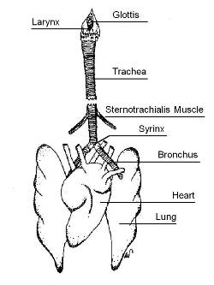
After air passes through the cranial larynx, it continues through the trachea. The trachea is made up of cartilaginous rings that keep it from collapsing due to the negative pressure present when a chicken breathes in air.
The syrinx (or caudal larynx), located near the end of the trachea, is the chicken's voice box. A chicken does not have vocal cords to produce sound. Instead, a chicken's "voice" is produced by air pressure on a valve and modified by muscle tension. It is not possible to remove the syrinx to prevent chickens from crowing.
After the syrinx, the trachea divides into two bronchi. In some respiratory diseases, tracheal plugs form and physically block the respiratory tract at the junction of the bronchi, thus suffocating the bird.
Each bronchus enters a lung. Avian lungs are relatively small, are firmly attached to the ribs, and do not expand. Birds have an incomplete diaphragm and chest muscles and a sternum that do not lend themselves to expansion in the way that a mammal's chest muscles and sternum do
Avian lungs contain parabronchi, which are continuous tubes that allow air to pass through the lung in one direction, and air sacs. The parabronchi are laced with blood capillaries, and it is here that gas exchange occurs. The air sacs, which fill a large proportion of the chest and abdominal cavity of a bird, are balloon-like structures at the ends of the airway system. The key to the avian respiratory system is that air moves in and out through distention and compression of the air sacs, not the lungs. The air sacs act as bellows to suck air in and blow it out and to hold part of the total air volume. At any given moment, air may be flowing into and out of the lung and being "parked" in the air sacs.
Air sacs are somewhat unique to avian species, found elsewhere only in certain reptiles. In the chicken, there are nine such sacs: an unpaired one in the cervical area, two interclavicular air sacs, two abdominal air sacs, two anterior thoracic air sacs, and two posterior thoracic air sacs.
Note; a bird's lungs operate differently from those of a mammal. Mammalian lungs contain many bronchi that lead to small sacs called alveoli. Because an alveolus (singular of alveoli) has only one opening, air flows into and out of the alveolus but not through it to the outside of the lung. In comparison, air passes through a bird's lungs in one direction. (In fact, the mammalian respiratory system is described as tidal because air goes in and out like the tide, whereas the avian respiratory system is described as nontidal.)

CARDIOVASCULAR SYSTEM
Blood
Blood is a unique fluid containing cells that is pumped by the heart around the body of animals in a system of pipes known as the circulatory system. It carries oxygen and nutrients to the cells of the body and removes waste products like carbon dioxide from them. Blood is also important for keeping conditions in the body constant, in other words for maintaining homeostasis. It helps keep the acidity or pH stable and helps maintain a constant temperature in the body. Blood also has an important role in defending the body against disease
The top layer consists of a light yellow fluid, the plasma, and the bottom layer consists of red blood cells (RBCs). This consists of the white blood cells (WBCs) The above procedure is usually done more rapidly by placing the blood sample in a centrifuge for a few minutes. This machine acts like a super spin drier rotating about 10,000 times a minute and packing the heavier particles (red blood cells) at the bottom of the tube. The sample that results is called the packed cell volume (P.C.V.) or haematocrit. It is a very useful measurement of the concentration of red blood cells in the blood. For most animals the packed cell volume is in the range 30-45%. If it is lower than this it means that the concentration of red blood cells is low and the animal is anaemic. If the reading is above this range it may mean the animal is dehydrated. Animals that live at high altitudes also have high P.C.V.s to compensate for the low oxygen concentration there.
Plasma
Plasma consists of water (91%) in which many substances are dissolved. These dissolved substances include:*.salts (or electrolytes)*.proteins*.nutrients*.waste products*.dissolved gases (mainly carbon dioxide)*.and other chemicals like hormones . Salts in the plasma are in the form of ions or electrolytes which include sodium, potassium, calcium, chloride, phosphate and bicarbonate. Plasma transports these ions to where they are needed e.g. calcium required by the bones, they also help keep the osmotic pressure and acid-base balance (pH) of the blood within the required levels.
Blood Proteins
The proteins in the blood plasma are large molecules with important functions. Some contribute to the osmotic pressure and the viscosity (thickness) of the blood, and so help keep the blood volume and pressure stable. Others act as antibodies that attack bacteria and viruses, and yet others are important in blood clotting. Nutrients that are absorbed from the gut and transported to the cells in the plasma include amino acids, glucose, fatty acids and vitamins. Waste products include urea from the breakdown of proteins.
Red Blood Cells
Red blood cells are also known as RBCs or erythrocytes. They are what make blood red. When you look at a blood smear through a microscope, as you will in one of the practical classes, you will see that RBCs are by far the most common cells in the blood. (In fact there are about 5 million per millilitre). If you focus on an individual RBC you will see that they are shaped like discs or doughnuts with a thin central portion surrounded by a fatter margin. This shape has all sorts of advantages, one being that enables the cells to fold up and pass along the narrowest blood capillaries
The mature RBCs of mammals have neither nucleus nor other organelles and can be thought of as sacks of haemoglobin. Haemoglobin is a red coloured protein containing iron, which joins with oxygen so the blood can transport it to body cells. RBCs are made continuously in the bone marrow and live about 120 days. They are then destroyed in the liver and spleen and the molecules they are made from recycled to make new RBCs. Anaemia results if the rate at which RBCs are destroyed exceeds the rate at which RBC'c are 'produced'. Note that if you happen to look at bird’s, reptiles, frogs or fishes blood down the microscope you will see that these vertebrates all have RBCs with a central nucleus.
White Blood Cells
White blood cells or leucocytes are far less numerous than red blood cells. In fact there is only about one white cell for every 1000 red blood cells. Rather than being white, they are actually colourless as they contain no haemoglobin although unlike RBCs they do have a nucleus. If you make a blood smear and look at it under the microscope it is difficult to see the white blood cells at all. To make them visible you need to stain them with special dyes or stains. There are a variety of stains that can be used, but most dye the nucleus a dark purple or pink colour. The stains may also show up the granules present in the cytoplasm of some white blood cells. White blood cells are divided into two major groups depending on the shape of the nucleus and whether or not there are granules in the cytoplasm.
1. Granulocytes or polymorphonuclear leucocytes (“polymorphs” or “polys”) have granules in the cytoplasm and a purple lobed nucleus . The most common (neutrophils) can squeeze out of capillaries and are involved in engulfing and destroying foreign invaders like bacteria). Some (eosinophils) combat allergies and increase in numbers during parasitic worm infections. Others (basophils) produceheparinthat prevents the blood from clotting.
2. Agranulocytes or monomorphonuclear leucocytes have a large unlobed nucleus and no granules in the cytoplasm. There are two types of agranulocytes. The most numerous are lymphocytes that are concerned with immune responses. The second type is the monocyte that is the largest blood cell and is involved in engulfing bacteria etc. by phagocytosis
Platelets
As well as red and white blood cells, the blood also contains small irregular shaped fragments of cells known as platelets. They are involved in the clotting of the blood.
Transport Of Oxygen
The purpose of the haemoglobin in red blood cells is to carry oxygen from the lungs to the tissues. In fact it allows the blood to carry about 25 times more oxygen than it would be able to without any haemoglobin. When oxygen concentrations are high, as in the blood capillaries in the lungs, haemoglobin combines with oxygen to form a compound called oxyhaemoglobin. This compound is bright red and makes the oxygenated blood that spurts from a damaged artery its characteristic bright red colour. When the blood reaches the tissues where the oxygen concentrations are low, the oxygen separates from the haemoglobin and diffuses into the tissues. The haemoglobin in most veins has given up its oxygen and the blood is called deoxygenated blood. It is a purple-red colour.
Carbon Monoxide Poisoning
Carbon monoxide is a colourless, odourless gas found in car exhaust fumes and tobacco smoke. It combines with haemoglobin just like oxygen but does not let go. This means the haemoglobin molecules are not available to carry oxygen to the tissues and the animal or human suffocates. Carbon monoxide poisoning is often fatal but can be treated by giving the patient pure oxygen that slowly replaces the carbon monoxide. This could be conceived numerically as a probability issue: carbon monoxide binds 200 times stronger than oxygen to the iron atom in haemaglobin, but this bond I has dynamic states where the CO molecule moves away temporarily from the iron atom and then it depends on chances of an oxygen atom being near enough to the iron atom to takeover the electrostatic bond. if there are enough oxygen molecules around, the carbon monoxide molecule is crowded out and moved further away from the iron atom , enough to overcome the 200 times attractivity of carbon monoxide to the iron moiety.
Transport Of Carbon Dioxide
Carbon dioxide is a waste gas produced by cells. It diffuses into the blood capillaries where it is carried to the lungs in the blood. Most is carried in the plasma as bicarbonate ions but a small amount is dissolved directly in the plasma and some combines with haemoglobin.
Transport Of Other Substances
The blood carries water to the cells and organs as well as soluble food substances (sugars, amino acids, fattyacids and vitamins) and hormones dissolved in the plasma. These are delivered to the cells via thetissue fluid that surrounds them. Blood also picks up the waste products like carbon dioxide and urea from the cells and is important in distributing the heat produced in the liver and muscles all over the body.
Blood Clotting
The mechanism that causes the blood to clot is easily seen when you or your animals are injured. However, minor injuries occur all the time in areas that experience wear and tear like the intestine, the lungs and the skin. Without the clotting mechanism, animals would quickly bleed to death from minor injury and internal haemorrhage. This is what happens in animals and people with clotting disorders like haemophilia, as well as animals that are poisoned with rat poisons like warfarin. Platelets are important in blood clotting. When blood vessels are damaged, substances released cause the blood platelets to disintegrate. This stimulates a complex chain of reactions, which causes the protein fibrinogen to be converted to fibrin. Fibrin forms a dense fibrous network over the wound preventing the escape of further blood.
Calcium and vitamin K are essential for the clotting process and any deficiency of these may also lead to clotting problems.
Serum And Plasma
When blood clots it separates into the clot that contains most of the cells and platelets leaving behind a straw coloured fluid. This fluid is called serum. It looks just like plasma and is similar in composition except for one big difference. It doesn’t contain fibrinogen, the protein that forms the clot.
Anticoagulants
Anticoagulants are substances that interfere with the clotting process. When blood is collected for transfusion or testing it is often important to prevent it clotting and there are a number of different anticoagulants you can use for this. Tubes containing the different anticoagulants are coded with different colours for easy recognition.
1.Heparin(colour code - green) is a natural anticoagulant produced by the white blood cells but it is also used routinely in the laboratory with samples to be tested for heavy metals like lead.
2.EDTA(colour code – lavender) is used for routine blood counts.
3.Fluoroxylate(colour code – grey) is used for biochemical tests for glucose.
4.Citrate(colour code – light blue) is used for the storage of large quantities of blood, such as used in transfusions.
Haemolysis
Haemolysis is the breakdown of the plasma membrane of red blood cells to release the haemoglobin. We have already met this process when discussing osmosis, for haemolysis often occurs when red blood cells are placed in a hypotonic solution and water flows in through the semi permeable plasma membrane to swell and eventually burst the cell. It is therefore important when collecting blood from an animal to make sure there is no water in the syringe or tube. Too much movement due to shaking the tube or sucking up the blood too vigorously can also break down the plasma membrane and cause haemolysis
Blood Groups
If you have given blood recently you may know your blood group. It may be blood group O, A or B or even AB, the rarest group. Blood groups are the result of different molecules called antigens on the outside of red blood cells. These cause antibodies to be formed that attack viruses and bacteria. Knowledge of a person’s blood group is important when giving transfusions because if blood of another incompatible blood group is given to a patient the red blood cells stick together and block the blood vessels and may lead to death. Blood groups also exist in many animals. There are three blood groups in cats and great care has to be taken that the groups are compatible when transfusing exotic breeds. The situation is slightly different in dogs. They have a number of blood groups but there is usually no problem with the first blood transfusion a dog receives. However, this first transfusion sensitises the immune system so that a problem may arise with the second and subsequent transfusions.
Haemolysis can occur in the living animal when it is exposed to various poisons and toxins. This may happen when, for example, it eats a poisonous plant, is bitten by a snake or infected with bacteria that destroy red blood cells (haemolytic bacteria).
Blood Volume
Blood accounts for between 6-10% of the body weight of animals, varying with the species and the stage of life. Animals can not tolerate losses of greater than 3%of the total volume when the condition known as shock occurs.

Heart
heart is the pump that pushes the blood around the body in the blood vessels of the circulatorysystem. In fish the blood only passes through the heart once on its way to the gills and then round the rest of the body. However, in mammals and birds that have lungs, the blood passes through the heart twice: once on its way to the lungs where it picks up oxygen and then through the heart again to be pumped all over the body. The heart is therefore two separate pumps, side by side .The heart is situated in the thorax between the lungs and is protected by the rib cage. In some animals it is displaced slightly to the left-hand side. A tough membrane called the pericardium covers it. There is a narrow space between the pericardium and the heart that is filled with a liquid that acts as a lubricant.The heart of mammals is a hollow bag made of cardiac muscle (see chapter 4). The cavity inside the heart is divided into 4 chambers. The chambers on the right side are completely separate from the chambers on the left side. The two upper chambers are thin walled, and are called the atria(or auricles). The two lower chambers are thick walled and are called the ventricles.

Control Of The Heartbeat
The cardiac muscle of the walls of the heart contracts of its own accord. This can be demonstrated by the rather macabre experiment in which a small portion of heart muscle is removed and placed in a solution that is similar to blood. The tissue will continue to contract and relax for a time. In the normal functioning heart the pacemakeracts rather like the conductor of an orchestra and superimposes a unified beat upon the heart as a whole. The pacemaker is situated in the wallof the right atrium. The rate at which the heart beats is modified by a part of the brain called themedulla oblongata(see Chapter 14) and by the hormone adrenalin (see Chapter 16) which speeds up the heartbeat.The Coronary VesselsAlthough oxygenated blood passes through some of the chambers of the heart it can not supply the muscle of the heart walls with the oxygen and nutrients it needs. Special arteries called thecoronary arteriesdo this. These two arteries arise from the aorta and branch through the heart to deliver oxygen and nutrients to the cardiac muscles and collect carbon dioxide and wastes. Coronary veins return the blood to right hand side of the heart. Some of these vessels canbe seen on the outside surface of the heart (see diagram 8.11). Sometimes fatty deposits on the inside wall of the coronary artery block the blood flow to the heart muscle. If the obstruction is severe enough to damage the heart muscle due to inadequate blood supply a “heart attack” can result.

Summary*.
The heart is situated in the thorax between the lungs*.The heart is a hollow bag made ofcardiac muscle. It is divided into four chambers (right and left atria and right and left ventricles).*.Valves stop blood flowing backwards. The right and leftatrio-ventricular valvesprevent blood in the ventricles from flowing back into the atria. The semilunar valves at the entrance of the pulmonary artery and aorta prevent blood flowing back into the ventricles. The closing of the valves produces the heart sounds heard with a stethoscope.*.
There are 4 stages to the heart beat. 1. blood flows into the right and left atria. 2. The atria contract and blood flows into the ventricles. 3. The ventricles contract and the closing of the atrio-ventricular valves produces the first heart sound. 4. Blood flows to the lungs and body and when the ventricles stop contracting the closing of the semilunar valves produces the second heart sound.*.The coronary arteries supply the heart muscle with oxygenated blood.
Blood Circulation
The circulatory system is the continuous system of tubes through which the blood is pumped around the body. It supplies the tissues with their requirements and removes waste products. In mammals and birds the blood circulates through two separate systems - the first from the heart to the lungs and back to the heart again (the pulmonary circulation) and the second from the heart to the head and body and back again (the systemic circulation) –
The mammalian circulatory system The tubes through which the blood flows are the arteries, capillaries and veins. The heart pumps blood into arteries that carry it away from the heart. The arteries divide into very thin vessels called capillaries that form a network between the cells of the body. The capillaries then join up again to make veins that return the blood to the heart.
Arteries
Arteries carry blood away from the heart. They have thick elastic walls that stretch and can withstand the surges of high pressure blood caused by the heartbeat (the pulse, see later). The arteries divide into smaller vessels called arterioles. The hole down the centre of the artery is called thelumen. There are three layers oftissue in the walls of an artery. It is lined with squamous epithelial cells. The middle layer is the thickest layer. It made of elastic fibres and smooth muscle to make it stretchy. The outer fibrous layer protects the artery (see diagram 8.13). Thepulseis only felt in arteries.
The Pulse
The pulse is the spurt of high pressure blood that passes along the aorta and arteries when the left ventricle contracts. As the pulse of blood passes along an artery the elastic walls stretch. When the pulse has passed the walls contract and this helps push the blood along. The pulse is easily felt at certain places where an artery passes near the surface of the body. It is strongest near the heart and becomes weaker as it travels away from the heart. The pulse disappears altogether in the capillaries.
Capillaries
Arterioles divide repeatedly to form a network penetrating between the cells of all tissues of the body. These small vessels are called capillaries. The walls are only one cell thick and some capillaries are so narrow that red blood cells have to fold up to pass through them. Capillaries form networks in tissues called capillary beds. The capillary networks in capillary beds are so dense that no living cell is far from its supply of oxygen and food .
Note: All arteries carry oxygenated blood except for the pulmonary artery that carries deoxygenated blood to the lungs.

The Formation Of Tissue Fluid And Lymph
The thin walls of capillaries allow water, some white blood cells and many dissolved substances to diffuse through them. These form a clear fluid calledtissue fluid(orextracellular fluidorinterstitial fluid) that surrounds the cells of the tissues. The tissue fluid allows oxygen and nutrients to pass from the blood to the cells and carbon dioxide and other waste products to be removed from the tissues
me tissue fluid finds its way back into the capillaries and some of it flows into the blind-ended lymphatic vessels that form a network in the tissues. Once the tissue fluid has entered the lymphatics it is called lymphal though its composition remains the same. The lymph vessels have walls that are even thinner than the capillaries. This means that molecules and particles that are larger than those that can pass into the blood stream e.g. cancer cells and bacteria can enter the lymphatic system. These are then filtered out as the lymph passes through lymph nodes.
Veins
Capillaries unite to form larger vessels called venules that join to form veins. Veins return blood to the heart and since blood that flows in veins has already passed through the fine capillaries, it flows slowly with no pulse and at low pressure. For this reason veins have thinner walls than arteries although there have the same three layers in them as arteries . As there is no pulse in veins, the blood is squeezed along them by the contraction of the skeletal muscles that lay alongside them. Veins also have valves in them that prevent blood flowing backwards.Valves in a vein
Note: Most veins carry deoxygenated blood. The pulmonary vein that carries oxygenated blood from thelungs to the left atrium of the heart is an exception.

Regulation of Blood Flow
The flow of blood along arteries, arterioles and capillaries is not constant but can be controlled depending upon the requirements of the body. For example more blood is directed to the skeletal muscles, brain or digestive system when they are active. Regulation of the blood flow to the arterioles of the skin is also important in controlling body temperature. The size of the vessels is adjusted by the contraction or relaxation of smooth muscle fibres in their walls.
Oedema and Fluid Loss
Oedema is the swelling of the tissues due to the accumulation of tissue fluid. This may occur because the tissue fluid is prevented from returning to the bloodstream and accumulates in the tissues. This maybe caused by physical inactivity (e.g. long car or plane trips in humans) or because of imbalances in the proteins in the blood. This is what causes the “pot-belly” of the malnourished child or worm-infested puppy. Loss of body fluid can be caused not only by drinking insufficient liquid but also through diarrhea and vomiting or sudden loss of blood due to haemorrhage. The effect is to reduce the volume of the blood which decreases the blood pressure. This could be dangerous because the supply of adequate blood to the brain depends upon maintaining the blood pressure at a constant level. To compensate for the loss of fluid various mechanisms come into play. First of all the blood vessels contract in order to try and maintain the pressure. Then, since the loss of fluid tends to make the blood more concentrated and increases its osmotic pressure, fluid is drawn into the blood from the tissues by osmosis.
The Spleen
The spleen is situated near the stomach. It has a rich blood supply and acts as a reservoir of red blood cells. When there is a sudden loss of blood, as happens when a haemorrhage occurs, the spleen contracts to release large numbers of red blood cells into the circulation. The spleen also destroys old red cells and makes new lymphocytes but it is not an essential organ because its removal in adult life seems to cause few problems. In the foetus, the spleen makes both red and white cells.
Important Blood Vessels of The Systemic (Body) Circulation
Blood is pumped out into the body via the main artery, the aorta. This takes the blood to the head, the limbs and all the body organs. After passing through a network of fine capillaries, the blood is returned to the heart in the largest vein, the vena cava(see d.Arteries and veins to and from many organs often run alongside each other and have the same name e.g. the renal artery and vein serve the kidney, the femoral artery and vein serve the hind limbs and the subclavian artery and vein serve the forelimbs. However, blood to the head passes along the carotid artery and returns to the cranial vena cava via the jugular vein. One variation on this arrangement is found in the blood vessels that serve the digestive tract. A variety of arteries take blood from the aorta to the intestines but blood from the intestines is carried by the hepatic portal vein to the liver where the digested food can be processed. This vessel is unlike others in that it transports blood from one organ to another rather than to or from the heart like arteries or veins .
Blood Pressure
The blood pressure is the pressure of the blood against the walls of the main arteries. The pressure is highest as the pulse produced by the contraction of the left ventricle passes along the artery. This is known as the systolic pressure. Pressure is much lower between pulses. This is known as the diastolic pressure. Blood pressure is measured in millimetres of mercury. A blood pressure that is higher than expected is known as hypertension while a pressure lower than expected is known as hypotension
Summary
The circulatory system is double with the blood passing through the heart twice.*.Arteries carry blood away from the heart. They have thick elastic walls that stretch and can withstand the high pressure of the pulse.*.Capillaries are small, thin walled vessels that form a network between the cells of the tissues.*.Veins return low pressure blood to the heart. They have thinner walls than arteries.*.The pulse is the spurt of high pressure blood that passes along the arteries when the left ventricle contracts. It can be felt where arteries pass close to the body surface.*.Tissue fluid is the clear fluid that leaks from the capillaries and surrounds the cells of the tissues. Lymph forms when tissue fluid enters lymphatics.*.Important blood vessels include the vena cava, aorta, pulmonary artery, carotid artery, jugular vein, renal artery and vein and hepatic portal vessel

